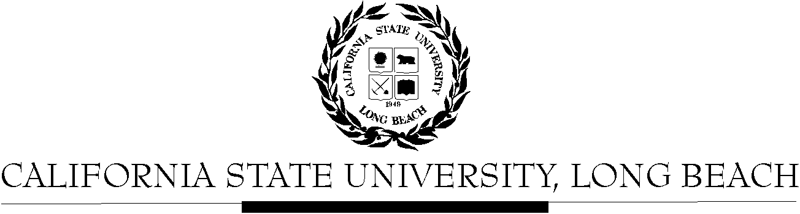

General Education Governing Committee

Agenda
April 13, 2015
2:00pm – 4:00pm – President’s Conference Room, BH-302

Please notify a member of the GEGC Executive Committee (Heather.Rae-Espinoza@csulb.edu, Danny.Paskin@csulb.edu, Hema.Ramachandran@csulb.edu or Vanessa.Red@csulb.edu) if you are unable to attend.

- Call to Order

- Approval of Agenda

- Approval of Minutes: GEGC Minutes posted on BeachBoard

- Announcements: There is one update for the tabled courses on BeachBoard (PHYS 390). We have four new courses for review.

- Course Reviews
  - Old Business
    - PHYS 390: Exploring Physics Teaching
      - Posted on BeachBoard/GE Course Proposals Fall 2014, AY 2014-2015
      - New to General Education
      - Request for Lifelong Learning & Self Development; Capstone: Writing Intensive, Integrative Learning
      - Discussion: See 12/8/14 Minutes
      - Updates available on BeachBoard
    - MATH 303: Reflections in Space and Time
      - Posted on BeachBoard/GE Course Proposals Spring 2015, AY 2014-2015
      - New to General Education
      - Request to add Foundations: Math; Capstone: Interdisciplinary, Writing Intensive
      - Discussion: See 3/23/15 minutes
      - No updates provided as of 4/6/15
    - MATH 309: Complexity and Emergence
      - Posted on BeachBoard/GE Course Proposals Spring 2015, AY 2014-2015
      - New to General Education
      - Request to add Foundations: Math; Capstone: Interdisciplinary, Writing Intensive
      - Discussion: See 3/23/15 minutes
      - No updates provided as of 4/6/15
    - R/ST/WGSS 303: Queer Spirit - Tabled
      - Posted on BeachBoard/GE Course Proposals Spring 2015, AY 2014-2015
      - New to General Education
      - Request to add Capstone: Writing Intensive; Lifelong Learning & Citizenship
      - Discussion: See 2/23/15 minutes
      - No updates provided as of 4/6/15
    - R/ST 313A: Introduction to Nahuatl Language and Ancient Mexican Codices - Tabled
      - Posted on BeachBoard/GE Course Proposals Spring 2015, AY 2014-2015
      - New to General Education
      - Request to add Humanities: Philosophy
      - Discussion: See 2/23/15 minutes
      - No updates provided as of 4/6/15
    - ECON 301: Economics of Public Issues
      - Posted on BeachBoard/GE Course Proposals Fall 2014, AY 2014-2015
      - New to General Education
      - Approved for Social Sciences & Citizenship; Capstone: Advanced Skills
      - Request for Writing Intensive tabled
      - Discussion: See 2/23/15 minutes
      - No updates provided as of 4/6/15
    - ITAL 345: Italian American Culture
      - Posted on BeachBoard/GE Course Proposals Fall 2014, AY 2014-2015
      - Existing to General Education
      - Approved to continue Capstone: Interdisciplinary; Social Sciences & Citizenship and add Human Diversity
      - Request Writing Intensive tabled
      - Discussion: See 2/23/15 minutes
      - No updates provided as of 4/6/15
    - A/ST 393: Japan: Continuities and Transformations - Tabled
      - Posted on BeachBoard/GE Course Proposals Spring 2015, AY 2014-2015
      - New to General Education
      - Request to add Capstone: Interdisciplinary, Writing Intensive
      - Discussion: See 2/9/15 and 2/23/15 minutes
      - No updates provided as of 4/6/15
    - HIST 305: Creating a Digital Past - Tabled
      - Posted on BeachBoard/GE Course Proposals Spring 2015, AY 2014-2015
      - New to General Education
      - Request for Capstone: Advanced Skills; Global Issues
      - Discussion: See 2/9/15 minutes
      - Pre-requisite issue continues as of 4/6/15
    - HIST 465: Seeing Latin America - Tabled
      - Posted on BeachBoard/GE Course Proposals Spring 2015, AY 2014-2015
      - New to General Education
      - Request to add Capstone: Interdisciplinary, Advanced Skills, Writing Intensive
      - Discussion: See 2/9/15 minutes
      - No updates provided as of 4/6/15
    - HIST 434: Medieval Spain: Conflict and Coexistence - Tabled
      - Posted on BeachBoard/GE Course Proposals Spring 2015, AY 2014-2015
      - New to General Education
      - Request to add Capstone: Writing Intensive
      - Discussion: See 2/9/15 minutes
      - No updates provided as of 4/6/15
    - ASAM 121: Contemporary Issues in Asian America
      - Posted on BeachBoard/GE Course Proposals Fall 2014, AY 2014-2015
      - Existing to General Education
      - Request to continue Social Science & Citizenship
      - Request to add Human Diversity
      - Discussion: See 12/8/14 Minutes
      - No updates provided as of 4/6/15
    - AIS/FEA 450: American Indian & Indigenous Cinema
      - Posted on BeachBoard/GE Course Proposals Fall 2014, AY 2014-2015
      - New to General Education
      - Request for Explorations: The Arts; Human Diversity
      - Discussion: See 12/8/14 Minutes
      - No updates provided as of 4/6/15
    - PHIL 405: Philosophy in Literature
      - Posted on BeachBoard/GE Course Proposals Fall 2014, AY 2014-2015
      - Existing to General Education
      - Request to continue Humanities: Philosophy; Capstone: Interdisciplinary
      - Request to add Capstone: Writing Intensive
      - Discussion: See 12/8/14 Minutes
      - No updates provided as of 4/6/15
    - PHIL 351: Political Philosophy - Tabled
      - Posted on BeachBoard/GE Course Proposals Fall 2014, AY 2014-2015
      - Existing to General Education
      - Request to continue Humanities: Philosophy; Capstone: Interdisciplinary
      - Request to add Capstone: Writing Intensive
      - Discussion: See 11/24/14 minutes
      - No updates provided as of 4/6/15

  - New Business
    - ENGL 380: Approaches to English Studies
      - Posted on BeachBoard/GE Course Proposals Fall 2014, AY 2014-2015
      - New to General Education
      - Request for Capstone: Writing Intensive and Integrative Learning
    - ENGL 444: Literature and Environment
      - Posted on BeachBoard/GE Course Proposals Fall 2014, AY 2014-2015
      - Existing to General Education
      - Request to continue: Capstone: Service Learning and Humanities: Literature
      - Request to add: Capstone: Writing Intensive
    - IST/SOC 405: Un-imagining the Middle East
      - Posted on BeachBoard/GE Course Proposals Fall 2014, AY 2014-2015
      - New to General Education
      - Request for Capstone: Writing Intensive and Global Issues
    - WGSS 370: Masculinities
      - Posted on BeachBoard/GE Course Proposals Fall 2014, AY 2014-2015
      - New to General Education
      - Request for Capstone: Writing Intensive; Social Sciences & Citizenship
    - Non-WI Capstone Guidelines
    - WI Capstone Guidelines
    - Lifelong Learning Guidelines

- Adjournment

- Future Agenda/Discussion Items

