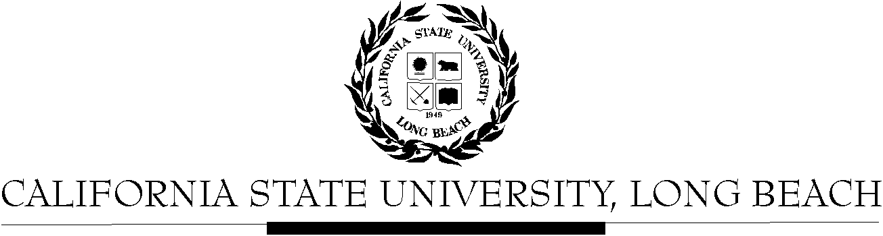

General Education Governing Committee

Agenda
April 25, 2016
2:00pm – 4:00pm – President’s Office, Conference Room, BH-302

Please notify a member of the GEGC Executive Committee (Heather.Rae-Espinoza@csulb.edu, Danny.Paskin@csulb.edu, Grace.Reynolds@csulb.edu or Vanessa.Red@csulb.edu) if you are unable to attend.

- Call to Order

- Approval of Agenda

- Approval of Minutes: GEGC Minutes posted on BeachBoard

- Announcements
  - No updates from the following tabled courses: AIS/FEA 450, A/ST 315, CLA/HHS 296, ENGR/NSCI 296, PHIL 156, and CHLS 375. Updates available for JOUR 104 on BeachBoard.

- GE Status Reports
  - Proposal to add Information Literacy to Advanced Skills Category
  - Update from Mary McPherson on GE Report

- Tabled Courses
    - AIS/FEA 450: American Indian and Indigenous Cinema – Tabled on 10/12/15 – No updates available
      - Posted on BeachBoard/GE Course Proposals Fall 2015, AY 2015-2016
      - New to General Education
      - Request for Explorations: The Arts; Human Diversity
      - Discussion available on 10/12/15 minutes
    - A/ST 315: Modern Korea – Tabled on 10/26/15 – No updates available
      - Posted on BeachBoard/GE Course Proposals Fall 2015, AY 2015-2016
      - New to General Education
      - Request for Explorations: Social Sciences & Citizenship; Global Issues
      - Discussion available on 10/26/15 minutes
    - CLA/HHS 296: Introduction to (Behavioral) Research Methods -Tabled on 1/25/16 – No updates available
      - Posted on BeachBoard/GE Course Proposals Fall 2015, AY 2015-2016
      - New to General Education
      - Request for Explorations: Life Sciences No Lab
      - Discussion available on 1/25/16 minutes
    - ENGR/NSCI 296: Introduction to Biomedical Research Methods - Tabled 2/8/16 – No updates available
      - Posted on BeachBoard/GE Course Proposals Fall 2015, AY 2015-2016
      - New to General Education
      - Request for Explorations: Life Sciences No Lab
      - Discussion available on 2/8/16 minutes
    - PHIL 156: Philosophy of Rock, Rap and Beyond – Tabled for HD 3/14/16 – No updates available
      - Posted on BeachBoard/GE Course Proposals Fall 2015, AY 2015-2016
      - New to General Education
      - Request for Explorations: The Arts; Human Diversity
      - Discussion available on 3/14/16 minutes
    - CHLS 375: Latinas and the Prison System: A Comparative Perspective – Tabled 3/14/16 – No updates available
      - Posted on BeachBoard/GE Course Proposals Fall 2015, AY 2015-2016
      - New to General Education
      - Request for Capstone: Interdisciplinary
      - Discussion available on 3/14/16 minutes
    - JOUR 104: Social Media Communications – Tabled 3/14/16 – Updates available on BeachBoard
      - Posted on BeachBoard/GE Course Proposals Fall 2015, AY 2015-2016
      - New to General Education
      - Request for Explorations: Lifelong Learning & Self Development
      - Discussion:
        - Clarification for the parts of the SCO that address Oral Communication as a GE designation can be ignored for now because the department is not requesting that GE designation. Originally, the department initially included Oral Communication but it was tabled at the college level and there will be a bigger discussion about this issue. The committee would like to have that portion of the SCO removed.
        - Recommendations: references to oral communication should be removed, essential skills for oral communication should be more direct
      - Motion to table – with one abstention

- Course Reviews
  - New Business
    - SCED 404: The Nature of Science and Scientific Reasoning
      - Posted on BeachBoard/GE Course Proposals Fall 2015, AY 2015-2016
      - New to General Education
      - Request for Capstone: Writing Intensive
    - HDEV 307: Approaches to Childhood
      - Posted on BeachBoard/GE Course Proposals Fall 2015, AY 2015-2016
      - Existing to General Education
      - Request to continue Social Sciences & Citizenship, Lifelong Learning & Self Development, Capstone: Interdisciplinary
      - Request to add Global Issues
    - PHIL 351: Political Philosophy
      - Posted on BeachBoard/GE Course Proposals Fall 2015, AY 2015-2016
      - Existing to General Education
      - Request to continue Humanities: Philosophy, Capstone: Interdisciplinary
      - Request to add Capstone: Writing Intensive

- Elect next year’s chair, vice chair, and secretary

- Adjournment

