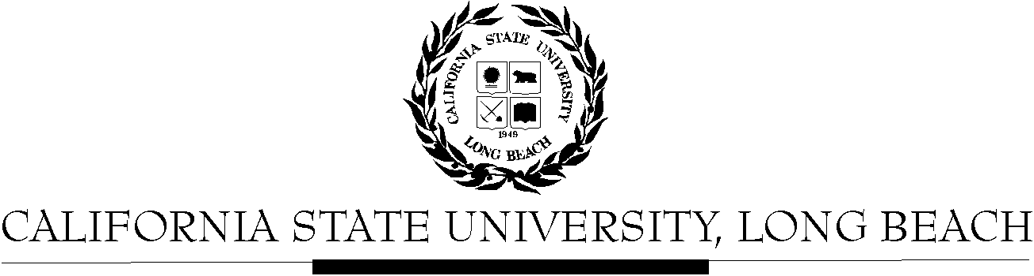

General Education Governing Committee

Agenda
November 14, 2016
2:00pm – 4:00pm – Office of the President Conference Room, BH-302

Please notify a member of the GEGC Executive Committee (Danny.Paskin@csulb.edu, Grace.Reynolds@csulb.edu Ruth.Piker@csulb.edu or Vanessa.Red@csulb.edu) if you are unable to attend.

- Call to Order

- Approval of Agenda

- Approval of Minutes: GEGC Minutes from 10-24-16 posted on BeachBoard

- Announcements

- Items still tabled:
    - CHLS 100: Introduction to Chicano & Latino Studies
    - IST/WGSS 339: Global Feminisms
    - CHLS 345: Latino/a Leadership in STEM
    - EDEC 200: Introduction to Early Childhood Education

- Current Business
  - To be Untabled: None
  - New Discussion Items:
    - Quick discussion regarding Academic Senate Retreat
    - COMM 300: Survey Rhetorical Theory
      - Posted on BeachBoard/GE Course Proposals Fall 2016
      - Existing to General Education
      - Request for Decertification from Explorations: Philosophy
    - PHIL 101: The Meaning of Life
      - Posted on BeachBoard/GE Course Proposals Fall 2016
      - New to General Education
      - Request for Explorations: Humanities/Philosophy, and for Lifelong Learning & Self-Development
    - AMST 142: Race and Hollywood
      - Posted on BeachBoard/GE Course Proposals Fall 2016
      - New to General Education
      - Request for Explorations: The Arts, and Human Diversity
    - AMST 152: Surfing and American Culture
      - Posted on BeachBoard/GE Course Proposals Fall 2016
      - New to General Education
      - Request for Explorations: Social Sciences & Citizenship
    - HIST 420: Israel: History, Peoples and Cultures
      - Posted on BeachBoard/GE Course Proposals Fall 2016
      - New to General Education
      - Request for Explorations: Social Sciences & Citizenship, and Capstone: Interdisciplinary

    - HIST 465: Seeing Latin America
      - Posted on BeachBoard/GE Course Proposals Fall 2016
      - New to General Education
      - Request for Explorations: The Arts, and Capstone: Writing Intensive
    - DESN 367: History and Theory of Architecture
      - Posted on BeachBoard/GE Course Proposals Fall 2016
      - New to General Education
      - Request for Explorations: Other Humanities, and Explorations: Social Sciences & Citizenship
    - ASAM 332: Korean American Experience
      - Posted on BeachBoard/GE Course Proposals Fall 2016
      - New to General Education
      - Request for Explorations: Lifelong Learning & Self-Development

- Future Business:
  - The following classes must be revised and resubmitted due to key issues, but will probably be soon reviewed by GEGC: AMST 419, ANTH 478, ASAM 330, ASAM 331, ASAM 334, ASAM 352, ASAM 353, GERM 397

- Adjournment

- Future Agenda/Discussion Items

