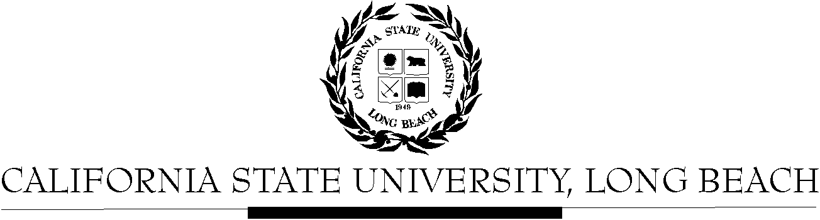

General Education Governing Committee

Agenda
September 26, 2016
2:00pm – 4:00pm – Office of the President Conference Room, BH-302

Please notify a member of the GEGC Executive Committee (Danny.Paskin@csulb.edu, Grace.Reynolds@csulb.edu Ruth.Piker@csulb.edu or Vanessa.Red@csulb.edu) if you are unable to attend.

- Call to Order

- Approval of Agenda

- Approval of Minutes: GEGC Minutes from 09-12-16 posted on BeachBoard

- Announcements

- Items still tabled:
    - CHLS 100: Introduction to Chicano & Latino Studies
    - IST/WGSS 339: Global Feminisms
    - CHLS 345: Latino/a Leadership in STEM

- Current Business
  - To be Untabled: None
  - New Submissions:
    - EDEC 200: Introduction to Early Childhood Education
      - Posted on BeachBoard/GE Course Proposals Fall 2016
      - New to General Education
      - Request for Explorations: Social Sciences & Citizenship
    - CHLS 375: Latinos and the Prison System: A Comparative Perspective
      - Posted on BeachBoard/GE Course Proposals Fall 2016
      - New to General Education
      - Request for Capstone: Interdisciplinary

- Future Business: None

- Adjournment

- Future Agenda/Discussion Items

