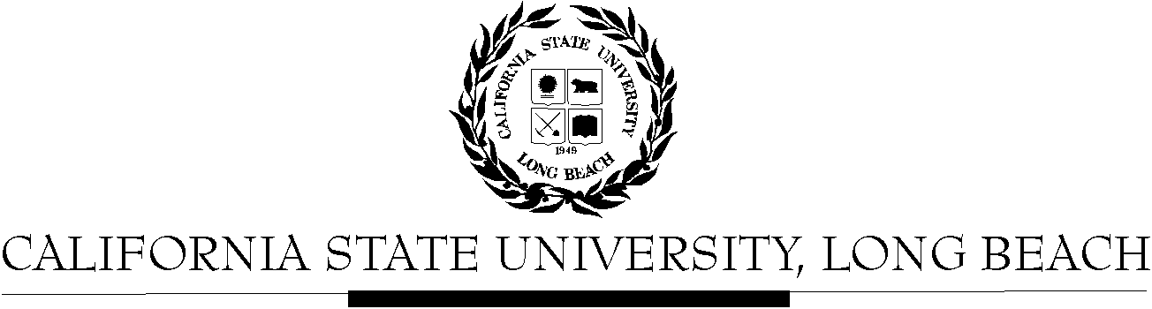

General Education Governing Committee

Agenda
August 22, 2016
2:00pm – 4:00pm – Office of the President Conference Room, BH-302

Please notify a member of the GEGC Executive Committee (Danny.Paskin@csulb.edu, Grace.Reynolds@csulb.edu Ruth.Piker@csulb.edu or Vanessa.Red@csulb.edu) if you are unable to attend.

- Call to Order

- Approval of Agenda

- Approval of Minutes: GEGC Minutes posted on BeachBoard

- Announcements
  - Welcome/Introductions
  - Description of GEGC process for 2016-17
    - Schedule – meeting second and fourth Mondays, from 2pm-4pm at BH-203
      - Fall: Aug. 22, Sep. 12, Sep. 26, Oct. 10, Oct. 24, Nov. 14, Nov. 28, Dec. 12
      - Spring: Jan. 23, Feb. 13, Feb. 27, Mar. 13, Apr. 10, Apr. 24, May 8
    - Agendas (via email), minutes and documents for review (via Beachboard)
    - Deadlines
  - Role of GEGC and GEGC members

- Items still tabled: None

- Current Business
  - To be Untabled: None
  - Proposal to adding a member of Academic Programs as an ex-officio member of GEGC
  - CEPC Liaison Election
  - Information Literacy Proposal
  - New Submissions:
    - CHLS 100: Introduction to Chicano & Latino Studies
      - Posted on BeachBoard/GE Course Proposals Fall 2016
      - Existing to General Education
      - Request to delete Social Sciences & Citizenship
      - Request for Critical Thinking
    - CHLS 430: The Latino Transnational Experience in the Caribbean: Empire, Reform and Revolution
      - Posted on BeachBoard/GE Course Proposals Fall 2016
      - Existing to General Education
      - Request to continue Social Sciences & Citizenship
      - Request for Global Issues
    - IST 399: Contemporary Global Divisions of Labor
      - Posted on BeachBoard/GE Course Proposals Fall 2016
      - New to General Education
      - Request for Social Sciences & Citizenship, Capstone: Global Issues (please disregard request for Interdisciplinary capstone for now)
    - IST/WGSS 339: Global Feminisms
      - Posted on BeachBoard/GE Course Proposals Fall 2016
      - New to General Education
      - Request for Social Sciences & Citizenship, Capstone: Interdisciplinary, Global Issues

- Future Business:
  - CHLS 345: Latino/a Leadership in STEM
    - Posted on BeachBoard/GE Course Proposals Fall 2016
    - New to General Education
    - Request for Capstone: Writing Intensive; Human Diversity

- Adjournment

- Future Agenda/Discussion Items

