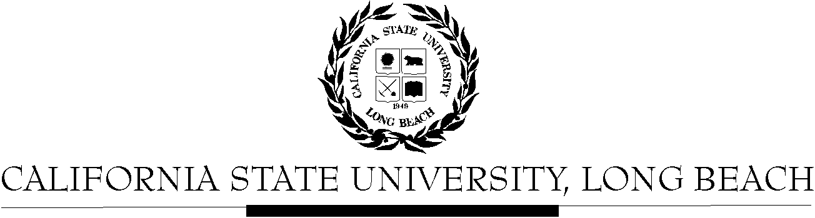

General Education Governing Committee

Agenda
April 24, 2017

2:00pm – 4:00pm – Office of the President Conference Room, BH-302

Please notify a member of the GEGC Executive Committee (Grace.Reynolds@csulb.edu or Ruth.Piker@csulb.edu) if you are unable to attend.

- Call to Order

- Approval of Agenda

- Approval of Minutes: GEGC Minutes from 4-10-2017 posted on BeachBoard

- A. Recertification of courses update
B. Discussion of Executive Order 1100; GEGC response by June 16, 2017

- Items still tabled:
    - CHLS 100: Introduction to Chicano & Latino Studies
    - CHLS 345: Latino/a Leadership in STEM
    - DESN 367: History and Theory of Architecture
    - IST/WGSS 339: Global Feminisms

- Current Business
  - New Submission:

    - UNIV 150: Research Career Exploration in Sciences – Denied 3/14/16
      - Posted on BeachBoard/GE Course Proposals Fall 2015, AY 2015-2016
      - New to General Education
      - Request for Explorations: Lifelong Learning and Self Development
      - Discussion:
        - Concerns include issues with the SLOs in the proposal, the course meeting the Lifelong Learning and Self Development category, as well as issues with the essential skills.
        - The committee feels this would be better suited towards Juniors as a somewhat “Junior Seminar” to provide information about Ph.D. programs to those students interested instead of to freshman students.
        - Motion to reject course – unanimously approved

- Future Business:
  - The following classes must be revised and resubmitted due to key issues, but will probably be soon reviewed by GEGC: ANTH 478, ASAM 330, ASAM 331, ASAM 334, ASAM 352, ASAM 353

- Adjournment

