Curriculum Calendars and Timelines
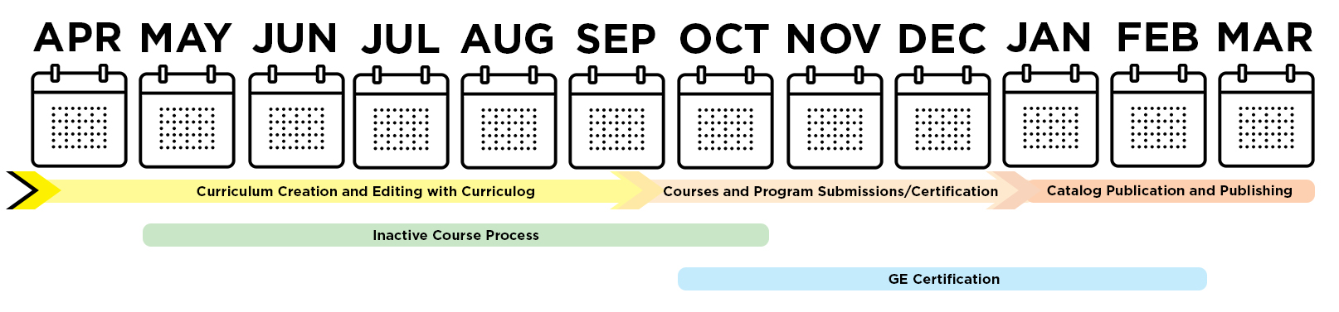
When looking at the below calendars and timelines, it's important to keep department, college, and Academic Senate committee schedules in mind to ensure all required reviews and approvals are complete before a submission deadline. For the Curriculum Office, six general timelines are helpful to track:

- Curriculum Creation and Editing with Curriculog
– April to October
- Inactive Course Process
– May to October
- Course and Program Submissions
– October (DUE) to December (Final Certification)
- GE Certification
– October to February
- New Degree Programs/Elevation of Options
– Often a Multi-Year Process
- Catalog Publication
– January to March

Details of these different timelines can be found in this document.
Strong recommendation: review the Enrollment Services Key Dates and Deadlines – which may impact your internal approval processes and curriculum timelines.

Curriculum Creation and Editing with Curriculog - April to October
The Curriculum Office’s calendar runs April through March, culminating with the publishing of the next University Catalog (effective in Fall) in March. The best time to receive training and direct support from the Curriculum Office starts in April. Most college curriculum committees start reviewing submissions at the start of the Fall Semester (August).
- April 15, 2024 - New Curriculum Cycle Begins
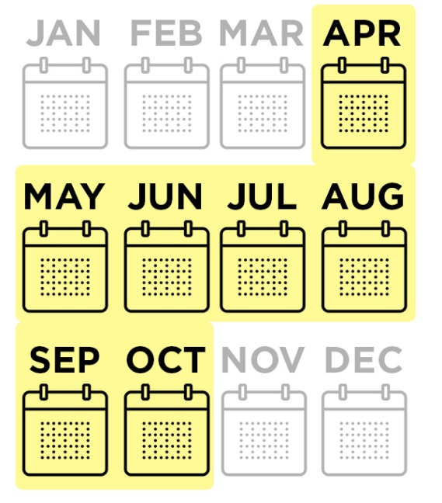
  - Curriculum Office composes a new draft of next Fall's Catalog – private from the public
  - Pre-existing curricular edits are added to the next Catalog (such as new programs which were waiting for implementation)
  - New Curriculog forms are developed and opened to users
    - College curriculum coordinators should submit new Curriculog role requests and updates to committee/approval rosters when applicable.
    - After an originator creates and launches a form in Curriculog - an initial technical review is conducted by the Curriculum Office on every form. From there forms are routed through college committees as determined by each college's curriculum practices.
    - Standard Course Outlines (SCOs) should accompany all applicable submissions.
- April through October – Curriculog Training Available
  - Curriculog Trainings are available by request – contact your college curriculum coordinator and catalog@csulb.edu for details and to schedule
    - Sessions can be 1:1, for small groups or large team workshops
    - Additional training and support resources are available via the Curriculum Website.

Inactive Courses - May to October
The policy of the CSU and of CSULB is that a course not offered within a five-year period is to be declared inactive. Colleges are provided with reports indicating which courses will be considered inactive in advance. Courses that are deactivated can be reactivated (with or without changes) via a curriculum form.
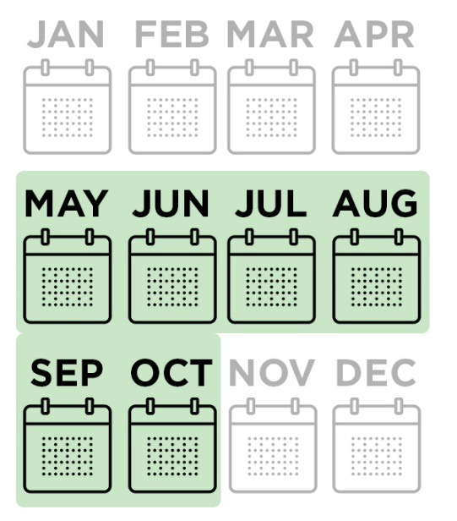
- May 14, 2024 - initial inactive reports distributed to colleges/department chairs
  - Reports list each course where the last term offered is five or more years. Colleges have the option to officially drop the course (delist it from the Catalog), inform the Curriculum Office that the course will be scheduled in an upcoming term, or to request a one-year, one-time exception for the course.
- September 6, 2024 - deadline for college/chairs responses
  - After this deadline, Curriculum, Articulation and Enrollment Services team examine the impact of the newly inactive courses and work with colleges/departments to confirm complimentary curriculum changes are made to ensure continuity in curricular listings.
- October 24, 2024 - inactive courses are formally certified
  - These courses are removed from the next Catalog (this includes their individual listing and any place they appear as a course requisites or degree requirement).
  - Enrollment Services teams will deactivate the courses in Peoplesoft.

Curriculum, GE and Program Deadlines - October to January
The homestretch of the curriculum cycle starts with the Curriculum Submission deadline and runs up until the Catalog's formal publishing in March of the next year.

Course (New, Drop, Reactivate, Change) and Program (Change) Submissions
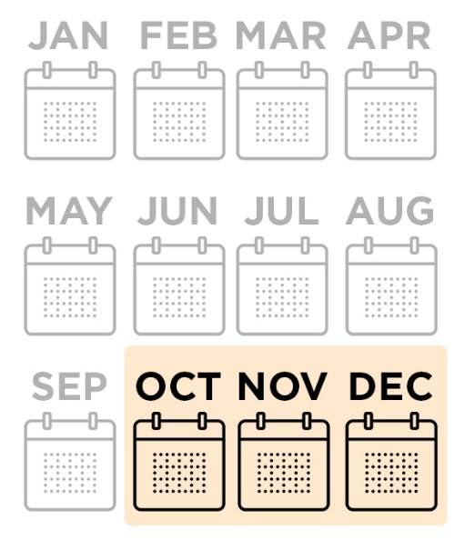
- October 30, 2024 - Curriculum Submissions via Curriculog Due
  - A traditional curriculum proposal is vetted by multiple areas - so it's important to keep in mind college curriculum committee meetings and schedules when composing a curricular form.
  - This October deadline means the forms have Associate Dean approval in Curriculog.
  - Curriculog forms close for the remainder of the Curriculum Cycle - reopening again in April.
  - The Curriculum Office reviews all submissions, vetting changes, running questions by submitters and Enrollment Services, and starts to build the certification documents. CSULB averages over 850 submissions each cycle - and each requires a proofreading and impact assessment.
- November 27, 2024 - Proposed Curriculum Certification Distributed
  - The Curriculum Office produces a complete document of all vetted changes and distributes to each college - starting a two-week challenge period.
  - The team then focuses on preparing for integration of the Curriculog form data with the Catalog Content Management System.
- December 17, 2024 - Formal Curriculum Certification Distributed
  - At the challenge period ends, the final certification is distributed and integrated into the following year's Catalog.

GE Certification
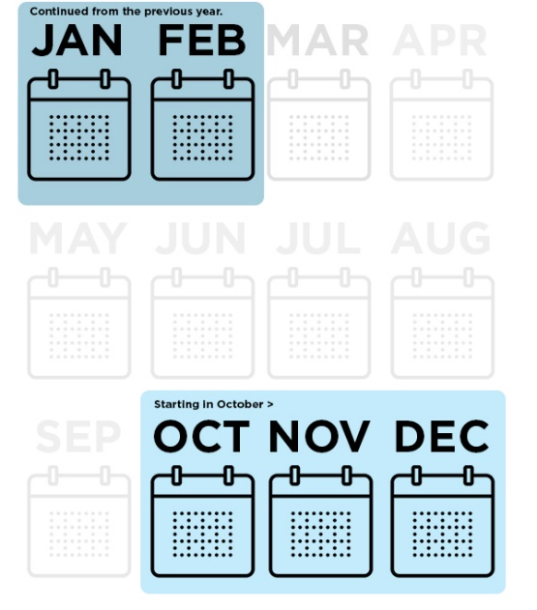
If you are planning on requesting curricular changes related to GE certification (adding, removing, or changing) for the next academic year, the following timeline is important. Proper review by committees overseeing GE Courses is required, and they have a limited meeting schedule. It is important to ensure that changes are prepared and submitted in advance.
- Early October, 2024 - Last day to submit GE requests and materials to GEGC Chair and GE Coordinator for Fall Review (check with the GEGC website to confirm submission dates)
- Mid-October 2024 – Enrollment Services deadline for coding GE courses into the schedule for Spring registration.
- October 30, 2024 - Curriculum Submissions Due
  - For GE, this includes changes to, drops of, or creation of new GE Courses.
- Early December 2024 - Last day GEGC can review GE requests. Check the GEGC meeting schedule.
- January/February 2025 - Last days the CEPC can approve a GE Supplement for its implementation in the upcoming Fall Academic Year. Check the CEPC meeting schedule and reach out in advance.
- Late January/Early February 2025 – Enrollment Services deadline for coding GE courses into the schedule for Fall registration.
- Late March, 2025 - Last day to submit GE requests and materials to GEGC Chair and GE Coordinator for Spring review (check with the GEGC website to confirm submission dates)
- Late May 20254 – Enrollment Services deadline for the end of the Academic Year for coding GE courses into the schedule for Spring registration. (This will be supplemented with October 2025 concurrence)

New Degree Programs or Elevation of Options to Degree Programs
If you are planning on implementing new degree-related curriculum for the 2024-25 Academic Year, there is a tight schedule for leading to a listing in the next catalog. It's best to anticipate a two-to-three-year process for implementation, advertising, and Catalog publication.
- All new program proposals or elevations need college approval prior to submission to the Vice Provost for Academic Programs. After the Vice Provost’s approval, proposals are forward to the to the Senate for CEPC and URC consideration.
  - Key Committee Dates
NOTE: These dates are guidelines – it is best to reach out to Senate Committees to see if it is possible to get on their agenda.
  - Submission of college-approved proposals to the Academic Programs team prior to August 1, 2024, is highly recommended.
    - This date will allow final Academic Programs review, submission to the Senate, multiple readings in the CEPC and URC, and final Senate review before sending to the President’s Office.
      - 2024-25 meeting dates will be posted on the CEPC website
      - 2024-25 meeting dates will be posted on the URC website
      - 2024-25 meeting dates will be posted on the CSULB Academic Senate website
    - Any submissions after September 1, 2024, will struggle to meet all steps to gain campus approvals by the curricular deadline of October 30, 2024. Any approvals that come after this period may delay the implementation/effective date.
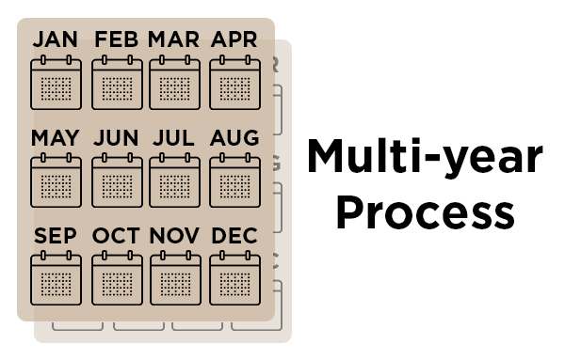
    - Note that some submissions may require additional approval by the CSU Chancellor’s Office. These approvals often have a four-month turnaround. Their decision should not impact the effective date of the program if returned by January 31, 2025.
- If creating new courses for these processes, that course needs to adhere to the Curriculog submission processes.
- Academic Master Plan
  - If you are planning on proposing a new program for the Academic Master Plan (AMP), that submission is due October, 30, 2024 (via Curriculog). Elevation of Options do not need to be placed on the AMP prior to going through the approval processes listed in this section. Notification of AMP submission deadlines (and supplemental submission periods offered by the CSU) will be communicated to the Associate Deans presiding over curriculum for their college.

Catalog Publication - January to March
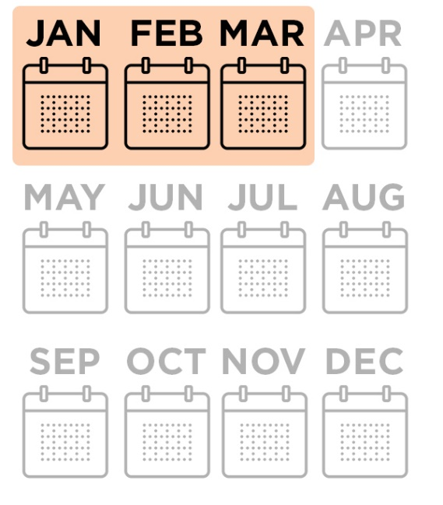
- January-February 2025
  - With a draft of the new Catalog now available, an edit copy for review (via the web) is distributed to each department. It is their opportunity to review Certification implementation and to make any non-curricular departmental edits to Catalog information necessary.
  - The Curriculum Office also updates information with administrative and system-level input on policies, regulations and general campus information.
  - At the end of the review period, Associate Deans that preside over their College's curriculum are asked for final approval of their content.
- March 2025
  - When all information is received and finalized, the newest Catalog is published.
  - The team archives the previous year, runs an accessibility review, and updates existing redirects to its key content.

