Curriculum Calendars and Timelines
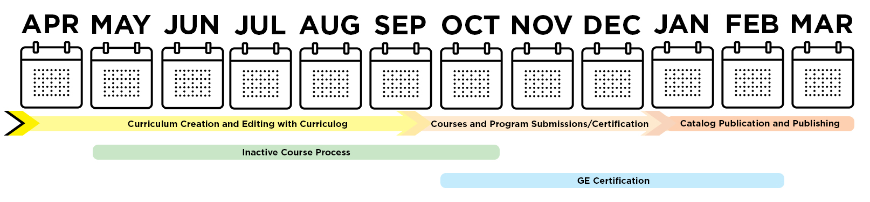
When looking at the below calendars and timelines, it's important to keep department, college, and Academic Senate committee schedules in mind in order to ensure all required steps/reviews/approvals are complete before a submission deadline. For the Curriculum Office, six general timelines are helpful to track:

- Curriculum Creation and Editing with Curriculog
– April to October
- Inactive Course Process
– May to October
- Course and Program Submissions
– October (DUE) to December (Final Certification)
- GE Certification
– October to February
- New Degree Programs/Elevation of Options
– Often a Multi-Year Process
- Catalog Publication
– January to March

Details of these different timelines can be found in this document.
Strong recommendation: review the Enrollment Services Key Dates and Deadlines – which may impact your internal approval processes and curriculum timelines.

Curriculum Creation and Editing with Curriculog - April to October
The Curriculum Office’s calendar runs run April through March, culminating with the publishing of the next University Catalog (effective in Fall) in March. The best time to receive training and direct support from the Curriculum Office starts in April. Most college curriculum committees start reviewing submissions at the start of the Fall Semester (August).
- April 1, 2021 - New Curriculum Cycle Begins
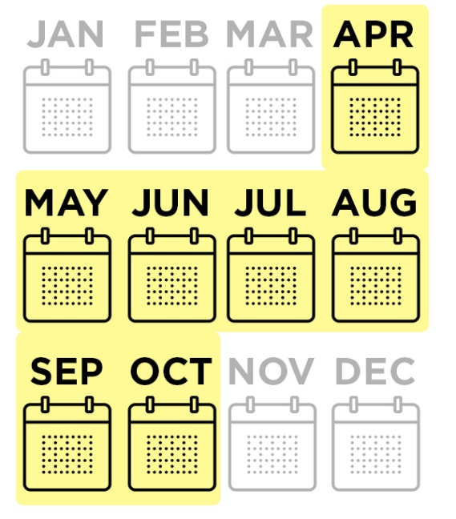
  - The Curriculum Office composes a new draft of next Fall's Catalog – private from the public
  - Pre-existing curricular changes and creations are edited into the next Catalog (such as new programs which were waiting for implementation)
  - New Curriculog forms are developed and opened to users
    - College curriculum coordinators should submit new Curriculog user requests and updates to committee/approval rosters when applicable.
    - After an originator creates and launches a form in Curriculog - an initial technical review is conducted by the Curriculum Office on every form. From there forms are routed through college committees as determined by each college's curriculum practices.
    - Standard Course Outlines (SCOs) should accompany all applicable submissions.
- April through October – Curriculog Training Available
  - Curriculog Trainings are available by request – contact your college curriculum coordinator and catalog@csulb.edu for details and to schedule
    - Sessions can be 1:1, for small groups or large team workshops
    - Additional training and support resources are available via the Curriculum Website.

Inactive Courses - May to October
The policy of the CSU and of CSULB is that a course not offered within a five-year period is to be declared inactive. Colleges are provided with reports indicating which courses will be considered inactive in advance. Courses that are deactivated, can be reactivated (with or without changes) via a curriculum form.
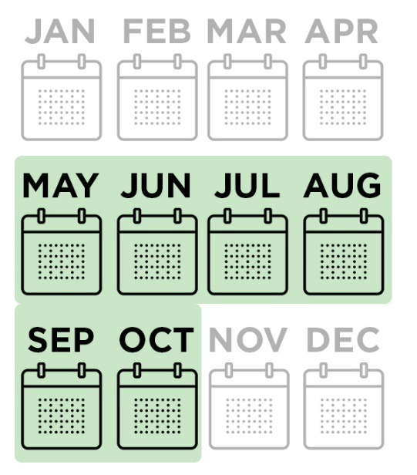
- May 10, 2021 - initial inactive reports distributed to colleges/department chairs
  - Reports list each course where the last term offered is five or more years. Colleges have the option to officially drop the course (delist it from the Catalog), inform the Curriculum Office that the course will be scheduled in an upcoming term, or to request a one-year, one-time exception for the course.
- September 3, 2021 - deadline for college/chairs responses
  - After this deadline, Curriculum, Articulation and Enrollment Services team examine the impact of the newly inactive courses and work with colleges/departments to confirm complimentary curriculum changes are made to ensure continuity in curricular listings.
- October 25, 2021 - inactive courses are formally certified
  - These courses are removed from the next Catalog (this includes their individual listing and any place they appear as a course requisites or degree requirement).
  - Enrollment Services teams will deactivate the courses in Peoplesoft.

Curriculum, GE and Program Deadlines - October to January
The homestretch of the curriculum cycle starts with the Curriculum Submission deadline and runs up until the Catalog's formal publishing in March of the next year.

Course (New, Drop, Reactivate, Change) and Program (Change) Submissions
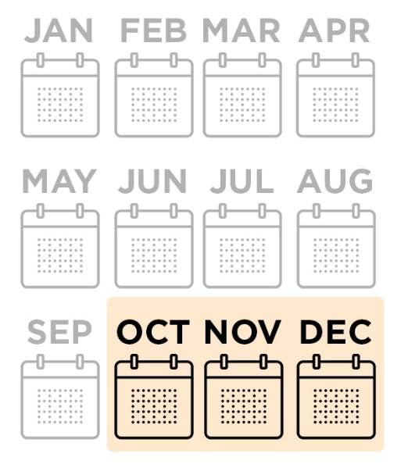
- October 29, 2021 - Curriculum Submissions via Curriculog Due
  - A traditional curriculum proposal is vetted by multiple areas - so it's important to keep in mind college curriculum committee meetings and schedules when composing a curricular form. This October deadline means the form has received all its approvals and is complete.
  - All course and program submissions are to be submitted through Curriculog.
  - Curriculog forms close for the remainder of the Curriculum Cycle - reopening again in April.
  - The Curriculum Office reviews all submissions, vetting changes, running questions by submitters and Enrollment Services, and starts to build the certification documents. CSULB has averaged over 1000 submitted forms over the last few years - and each requires a proofreading and impact assessment.
- November 29, 2021 - Proposed Curriculum Certification Distributed
  - The Curriculum Office produces a complete document of all vetted changes and distributes to each college - starting a two-week challenge period.
  - The team then focuses on preparing for integration of the Curriculog form data with the Catalog Content Management System.
- December 13, 2021 - Formal Curriculum Certification Distributed
  - At the challenge period ends, the final certification is distributed and integrated into the following year's Catalog.

GE Certification
If you are planning on requesting curricular changes related to GE certification (adding, removing or changing) for the next academic year, the following timeline is important. Proper review by committees overseeing GE Courses are required and they have a limited meeting schedule, so it is important to ensure changes are prepared and submitted in advance.
- Mid-October 2021 – Enrollment Services deadline for coding GE courses into the schedule for Spring registration.
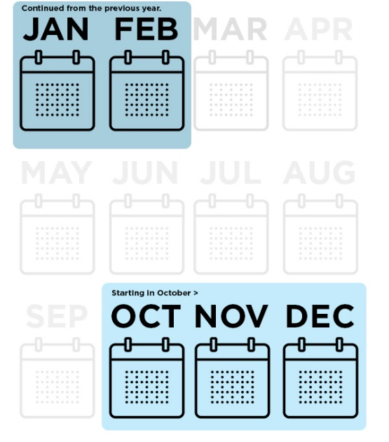
- Late Oct/Early Nov 2021 - Curriculum Submissions Due
  - For GE, this includes changes to, drops of or creation of new GE Courses.
- Early November 2021 - Last day to submit GE requests and materials to GEGC Chair and GE Coordinator
- Early December 2021 - Last day GEGC can review GE requests. Check the GEGC meeting schedule.
- January/February 2022 - Last days the CEPC can approve a GE Supplement for its implementation in the upcoming Fall Academic Year. Check the CEPC meeting schedule and reach out in advance.
- Late January/Early February 2022 – Enrollment Services deadline for coding GE courses into the schedule for Fall registration.
- Late May 2022 – Enrollment Services deadline for the end of the Academic Year for coding of GE courses into the schedule for Spring registration. (This will be supplemented with October 2021 concurrence)

New Degree Programs or Elevation of Options to Degree Programs
If you are planning on implementing new curriculum in the 2021-22 Academic Year, there is a tight schedule for approvals for the program to be listed in the following year's catalog. It's best to anticipate a two-to-three-year process for implementation, advertising and publication in the Catalog.
- All new program proposals must be approved by Departments, Colleges, and the Vice Provost prior to being forwarded to the Senate for CEPC and URC consideration.
  - Key Committee Dates
NOTE: These dates are guidelines – it is best to reach out to Senate Committees to see if it is possible to get on their agenda.
    - Mid-September 2021 - Last day to submit curriculum review material to CEPC. The committee will have limited meeting time prior to the curriculum submission deadline.
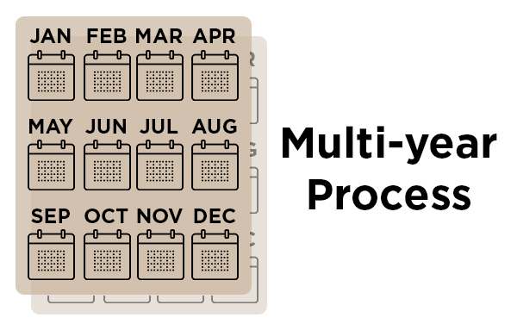
    - Mid-September 2021 - Last day for first reading by URC, with early October being the last day the committee can approve curriculum.
    - Mid October 2021 - is the last day the Academic Senate can have a first reading of curriculum, with the late October meeting being the last opportunity to approve new programs or elevated options prior to the curriculum Deadline.
    - October 29, 2021 - Curriculum Submissions Due - new programs or elevation of options that come after this date will not be included in the next Catalog - but held for the following year.
- If creating a new course for a new program or elevation of an option, that course also needs to adhere to the Curriculum Submission Deadline.
- Academic Master Plan
  - If you are planning on proposing a new program for the Academic Master Plan (AMP), that submission is due October 30, 2020 to the Curriculum Office. Elevation of Options do not need to be placed on the AMP prior to going through the approval processes listed in this section.

Catalog Publication - January to March
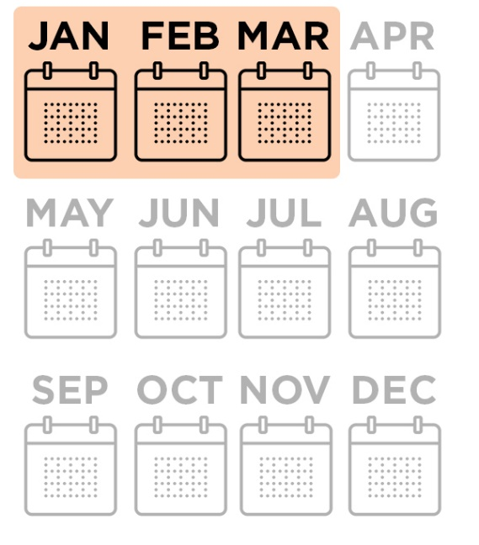
- January-February 2022
  - With a draft of the new Catalog now available, an edit copy for review (via the web) is distributed to each department. It is their opportunity to review Certification implementation and to make any to make non-curricular departmental edits to Catalog information necessary.
  - The Curriculum Office also updates information with administrative and system-level input on policies, regulations and general campus information.
  - At the end of the review period, Associate Deans that preside over their College's curriculum are asked for final approval of their content.
- March 2022
  - When all information is received and finalized, the newest Catalog is published.
  - The team archives the previous year, runs an accessibility review, and updates existing redirects to its key content.

