Balancing Bird and Climbing Bear

Kids can made birds that balance on their beaks and bears that climb up a piece of string. For a bird to balance, tape two pennies to the wings (as shown in Figure 1). For a bear to be able to climb, insert the piece of string as shown in Figure 2, hang the string on a hook or someone’s finger, and then pull the string down on the right, then left, then right again, etc. Templates for the bird and bear are given below.
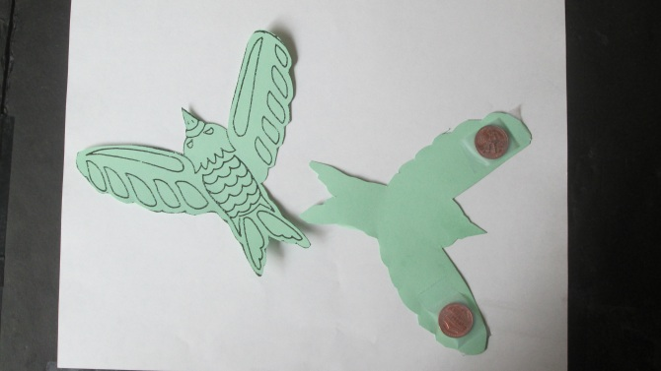
Figure 1.
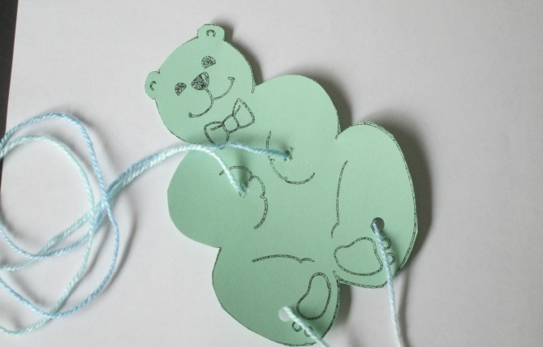
Figure 2.



