Optical Illusions
Are the inner circles the same size? Are these lines the same length?
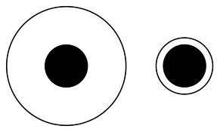
Are these lines the same length? Are these lines horizontal?
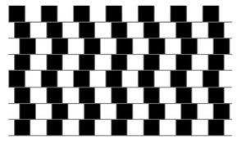
Are these lines straight? Is this a square?
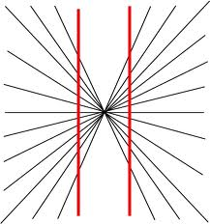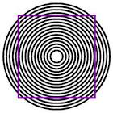

Are the inner circles the same size?

Are the men the same size? Is this a perfect circle?
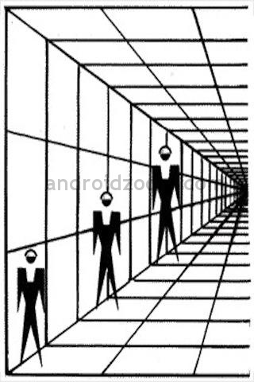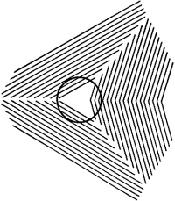
Are these shapes the same? Is this a square ?
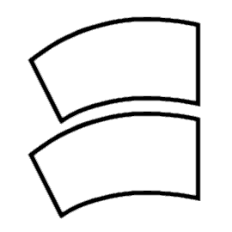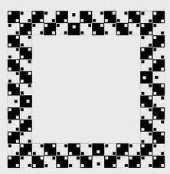
3D Optical Illusions – Impossible Objects
(these objects cannot be made but can be drawn)
How many legs does How many legs does
this elephant have? this giraffe have? 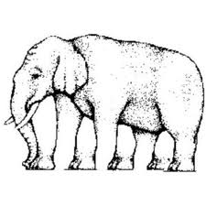 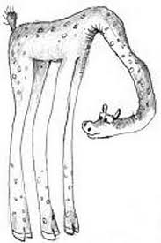

How many shelves do you see? How many prongs do you see?
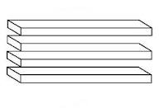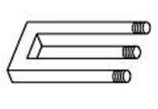
M.C. Escher’s Artwork
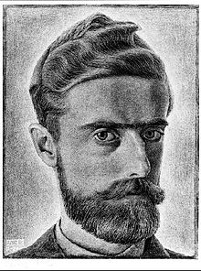
Maurits Cornelis Escher ( 1898 –1972) was a Dutch artist.

Are these never ending steps? Can a building like this exist?
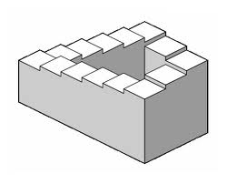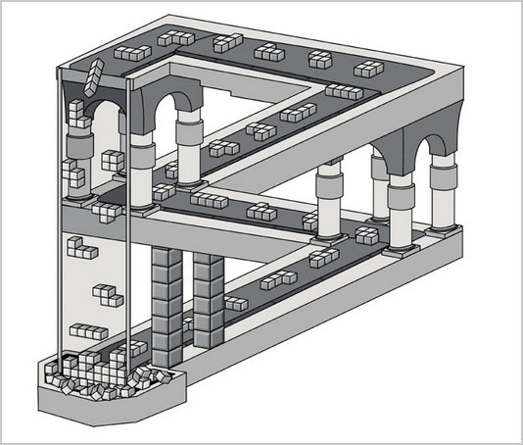
Can a building like this exist? Can a building like this exist?
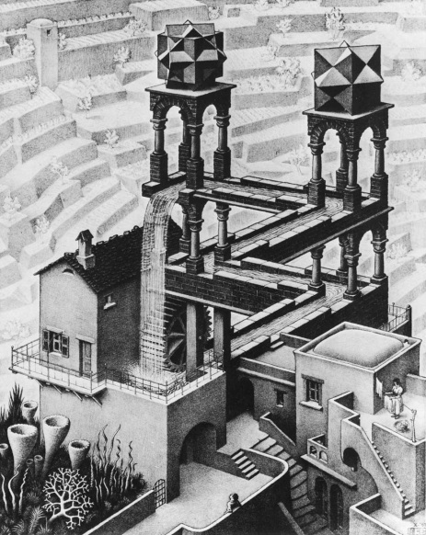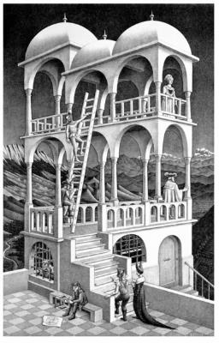
Are these never ending steps?


