Bell Shaped Curve
If we measure heights of adults and plot the histogram of the number of individuals against their heights, we will get an approximately bell shaped curve like this:
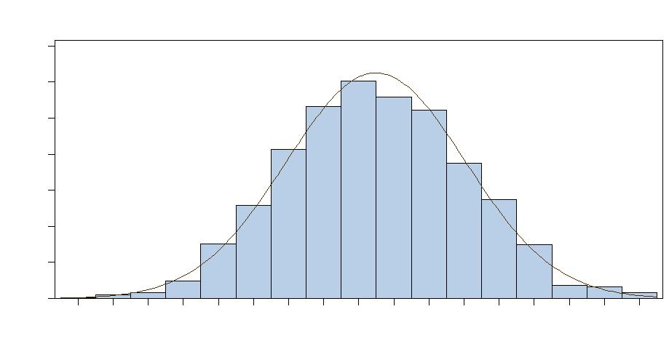
Most of the observations will be in the middle and a few people will be very tall or very short.
Activity. Drop marbles in the bean machine. Marbles are dropped from the top, and bounce left and right as they hit the pins. Eventually, they are collected at the bottom. What shape are the marbles forming into?
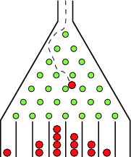

[An actual home-made bean machine was used and students dropped marbles.]


