1 Simplify the following Boolean functions by means of a three-variable map:

(a) (b)

2 Simplify the following Boolean Expressions using a map

(a)  (b) 

3 Simplify the following Boolean expressions, using a map

(a) 

(b) 

4 Find the minterms of the following expressions by first plotting each expression on a map:

(a) 

(b) 

5 Simplify the following Boolean functions by finding all prime implicants and essential prime implicants and applying the selection rule:

(a) 

(b) 

6 Simplify the following Boolean functions in product-of-sums form:

(a) 

(b) 

7 Simplify the following Boolean functions F together with the don’t-care conditions *d.* Find all prime and essential prime implicants and apply the selection rule.



8 An integrated circuit logic family has NAND gates with a fan-out of 8 standard loads and buffers with a fan-out of 16 standard loads. Show how the output signal of a single NAND gate can be applied to 38 other gate inputs using buffers. Assume that each input is one standard load.

9 The gates including inverters in the figure below have propagation delays of tpd= 0.5 ns. What is the propagation delay of the longest path through the circuit?

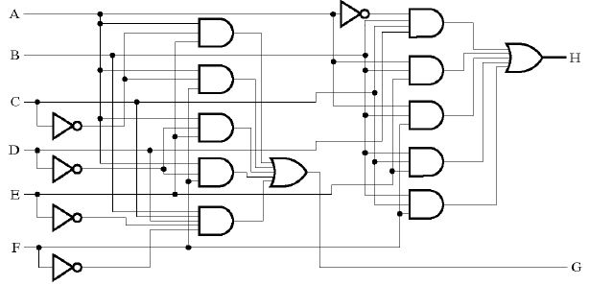

10 The waveform in the figure below is applied to an AND gate. Find the output of the AND assuming that:

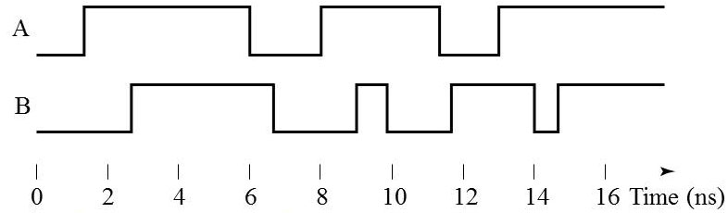

(a) it has no delay.



(b) it has a transport delay of 2 ns.



(c) it has an inertial delay of 2 ns with a rejection time of 1 ns.

