SAFETY GUIDE TO MARS PROJECT FIELD TRIP
Los Angeles to Santa Barbara Counties, July 2018

This field trip will visit relatively easily accessible roadcuts and coastal outcrops. Hikes are generally less than 1-1.5 miles roundtrip, but often require access from seaside bluffs. Safety considerations include walking on uneven rocky, cobbly or sandy beaches, slippery rocks on intertidal exposures, large surf, falling rocks from road cuts and natural cliff exposures, traffic near roadcuts, and normal hazards of highway driving. Poison oak, a plant that causes an allergic rash in some people, occurs in some areas, but can be avoided.

Rain is unlikely in July, but temperatures and conditions could range from cool, breezy, and foggy to hot. Therefore, it is best to come prepared—dress in layers. Bring a jacket to block coastal winds. All of the outcrops we’ll visit can be accessed wearing robust hiking or running shoes, but if you can bring hiking boots, they’ll be easier to navigate the rocky outcrops and provide better ankle and foot protection. A hat, sunscreen, and sunglasses will be important for many participants. A camera is recommended.

We will bring safety vests, a first aid kit, and plenty of fluids for hydration. All of the field trip sites are within cell phone range. Lunches are provided.

We strive to keep outstanding safety standards and have prepared this guide to help you be aware of the possible safety issues and make safe decisions. The field trip leaders have adequate equipment and contingency plans to cover all safety issues during this trip. Please ask any of the leaders or students on this trip if you have any questions.

ACCESS AND LIST OF POTENTIAL HAZARDS BY STOP

Paradise Cove, Malibu Beach
Flat, easy ~1-mile walk roundtrip beach walk with minor walking over rocky outcrops. Hazards are a few uneven rock outcrops and possibility of rogue waves. Possible rock fall from cliffs.

Goleta Beach
Flat, easy ~1-mile walk roundtrip beach walk with minor walking over rocky outcrops. Hazards are few uneven rock outcrops and possibility of rogue waves.

Arroyo Burro County Beach
Easy beach walk, < 1 mile one-way, but with long set of stairs (120’ high) down and up to beach. Hazards are few uneven rock outcrops and possibility of rogue waves. Possible rock fall from cliffs.

Sweeney Road, Lompoc – roadway hazards
Country road with light traffic. High-visibility safety vest is required. We will use orange traffic cones for added security in warning traffic of our presence. Possibility of loose rocks falling from road cut.

Imerys Mineral Diatomite Quarry – mining operations
East access and mostly flat walking. Primary hazards are that this is an active mine with large trucks, bulldozers and other equipment. Personal safety equipment will be provided (hard hats and safety vests) and representatives of the quarry will coordinate our location with mine operations.

GENERAL CONDITIONS AND HAZARDS

Road conditions
We will be driving mainly on paved roads with varying amounts of traffic.

Roadcuts
The Sweeney Road outcrop is on an active, but low-traffic, roadway. Be attentive and don’t stand in the road or cross without looking both ways. Safety vests will be worn.

Hiking
There will be only moderately strenuous hiking, but there will be minor to moderate beach walking or walking through soft sand on bluffs (up to ~1mile). Drink plenty of water and avoid dehydration. Robust hiking or running shoes are fine but hiking boots are better.

Poison oak
Poison oak is not present on the beaches, but may be at roadside at Sweeney Road or near the quarry. Summer is the growing season so it is very recognizable when fully in-leaf, but even when the shrub is dormant in the autumn, be careful not to touch this plant – its oils will give you a very uncomfortable rash. The leaders will point this plant out.

Wildlife
The biggest concern during the spring in California is the presence of ticks. If you have to walk through brush (unlikely on this trip), be aware and check yourself (especially in crevices) to ensure you do not have any. A picture is below to help with identification. If you are bitten, inform the leaders immediately.
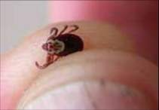

Most snakes in this area are harmless, but should you see one, stay away from it and inform the field leader. Rattlesnakes are the only venomous snakes in the area: a picture is below to help with identification. If you are bitten, inform the leaders immediately.
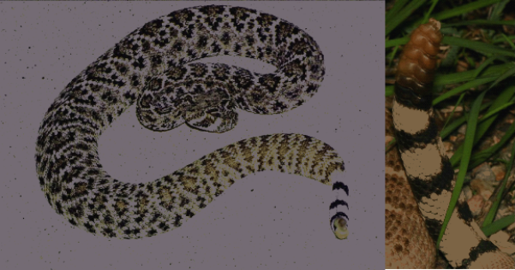

Again, few arachnids here are dangerous, but try to stay away from them. If you are bitten or stung, inform the leaders immediately. A picture of a brown recluse spider (the dangerous one) and a scorpion are below.
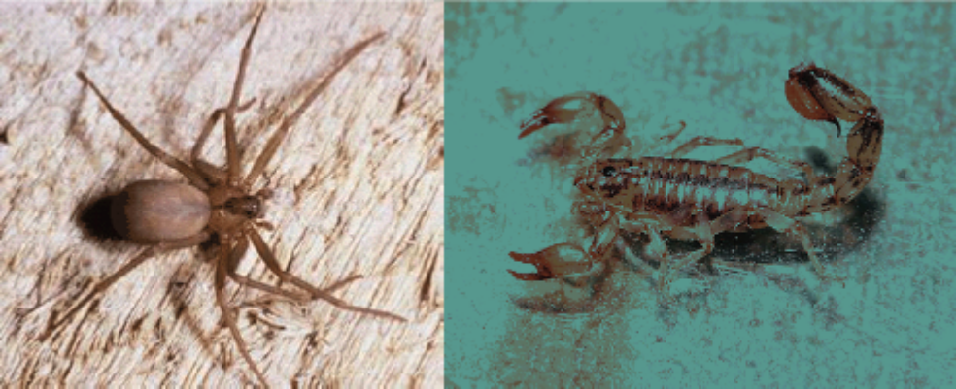

Mountain lions (pumas) are rarely seen in this area. However, should you encounter one, do not turn away from it. Rather, make noise and make yourself appear large.

COASTAL SAFETY

Weather is likely to be excellent, but please bring a jacket to the coastal outcrops – the fog and wind can be cold, even on a warm day inland.

The coast is a beautiful place to do geology but presents a few dangers. Never turn your back to the water when close to or within the swash zone and watch for rogue waves. Do not unintentionally venture close or into the water to avoid getting wet or pulled in. The water temperature can be very cold (50°F/10°C). Watch your footing – many coastal rocky outcrops are quite slippery.

EMERGENCY PHONE NUMBERS

USA country code is 1

Trip Leader Cell Phone Number
Rick Behl 949-201-0025

Los Angeles and Santa Barbara Counties

Long Beach Community Hospital, Long Beach
1720 Termino Avenue, Long Beach, CA ‎ 562-498-1000

Malibu Urgent Care Center
23656 Pacific Coast Hwy, Malibu, CA 90265 310-456-7551

Santa Barbara Cottage Hospital (Level II trauma center)
400 W Pueblo St, Santa Barbara, CA 93102 805-682-7111

Santa Barbara County Sheriff’s Office
805-681-4100 (Officer needed, non-emergency)

Lompoc Valley Medical Center
216 N Third St., Lompoc, CA 93436 805-736-3466

Walk-In Care & Family Care, Lompoc
217 West Central Ave., Suite G, Lompoc, CA ‎ 805-735-4292

California Highway Patrol West Los Angeles, CA)
310-642-3939

California Highway Patrol (Santa Maria, CA)
805-349-8728

California Highway Patrol (Buellton, CA)
805-688-5551

California Highway Patrol (Santa Barbara, CA)
805- 967-1234

