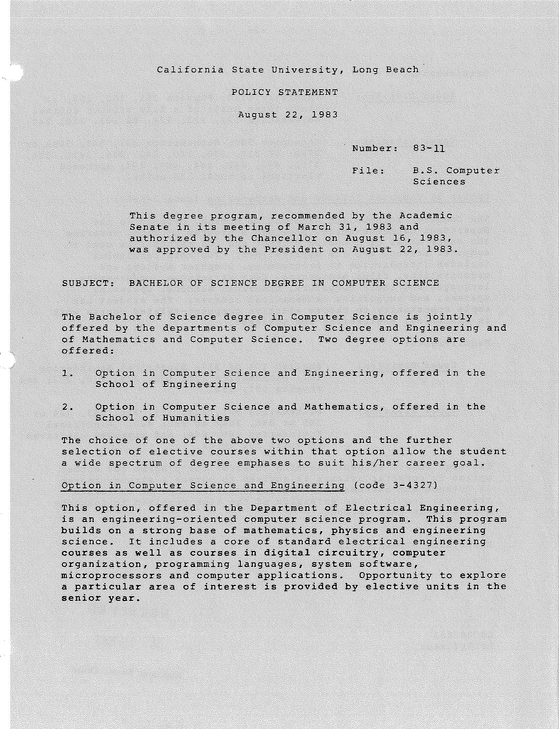

-2-

Requirements:

Lower Division:

Upper Division:
Chemistry lllA; Physics 151,152,154; at least three units of a life science course; Mathematics 122, 123, 224; EE 101, 210, 242.

Economics 300; Mathematics 321, 343, 346A or
370A; EE 310, 330, 340, 342, 346, 347L, 370,
370L, 440, 442, 444, 480, 494; approved
electives to total 135 units.

Option in Computer Science and Mathematics (code 3-6667)

The Computer Science and Mathematics option, offered in the Department of Mathematics, provides a program of study covering the major areas of computer science and the mathematics used in computer science and its applications. The core curriculum
includes introduction to programming, computer systems and organizations, files processing, data structures, programming languages and their compilers, numerical methods, operating systems, and supporting mathematical courses. The student has ample opportunity to choose elective computer-related course work in electrical engineering and business.

Requirements:

Lower Division:

Upper Division:
English 101 or 317; Electrical Engineering
101; Mathematics 122, 123, 224, 270, 272; and
Physics 151, 152.

Mathematics 321, 323, 325, 326, 343, 324 or
345 or 346, 364A or 380; 422. Electrical Engineering 440, 444; and approved electives to total 132 units.

The high school student planning to enter the program for either option in computer science is advised to pursue a strong program in science and mathematics. Deficiencies in some of the above areas may result in an extension of the time required to complete a program in this option.

EFFECTIVE: Immediately

ESC082683 APLPS1346Dl

