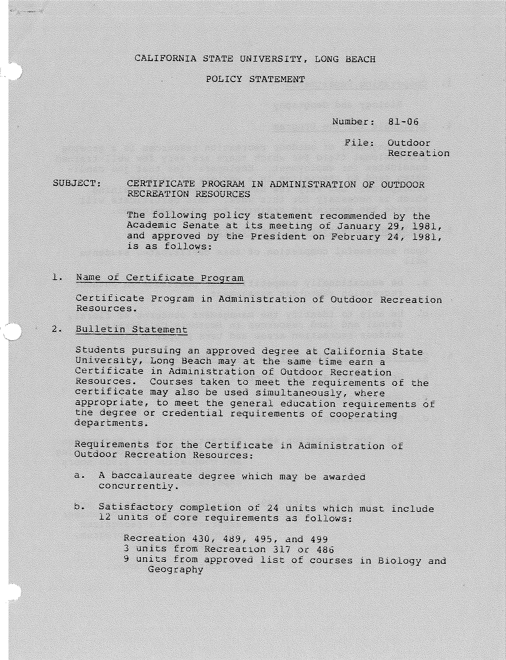

-2-

- Cooperating Departments Biology and Geography
- Rationale for the Program

The management of outdoor recreation resources is a growing professional field for which there are very few well-trained candidates for employment. Employers find that job candidates tend to specialize in a variety of related disciplines, but very few have the generalist training which is necessary for this work. This certificate will provide the generalist training for such employees.
- Goals and Objectives of the Program
Upon successful completion of this certificate, students will

  - be educationally competitive for positions in outdoor recreation resources management.

  - be able to identify the management concerns of floral, faunal and land resources in Southern California outdoor recreation areas and take proper action.

- Criteria for Eligibility for Acceptance into the Program
  - Grade point average {overall): 2.5
  - Open to all majors
  - Prerequisites:

(l) for Recreation 486: Recreation 484; or Recreation
211, 241, 312, senior standing and completion of 1,000 hours documented leadership experience.
- for Recreation 489: Instructor's permission and
1,500 hours paid or volunteer experience in a recognized outdoor recreation program, or Recreation 484.
- for Recreation 499: Consent of instructor.

