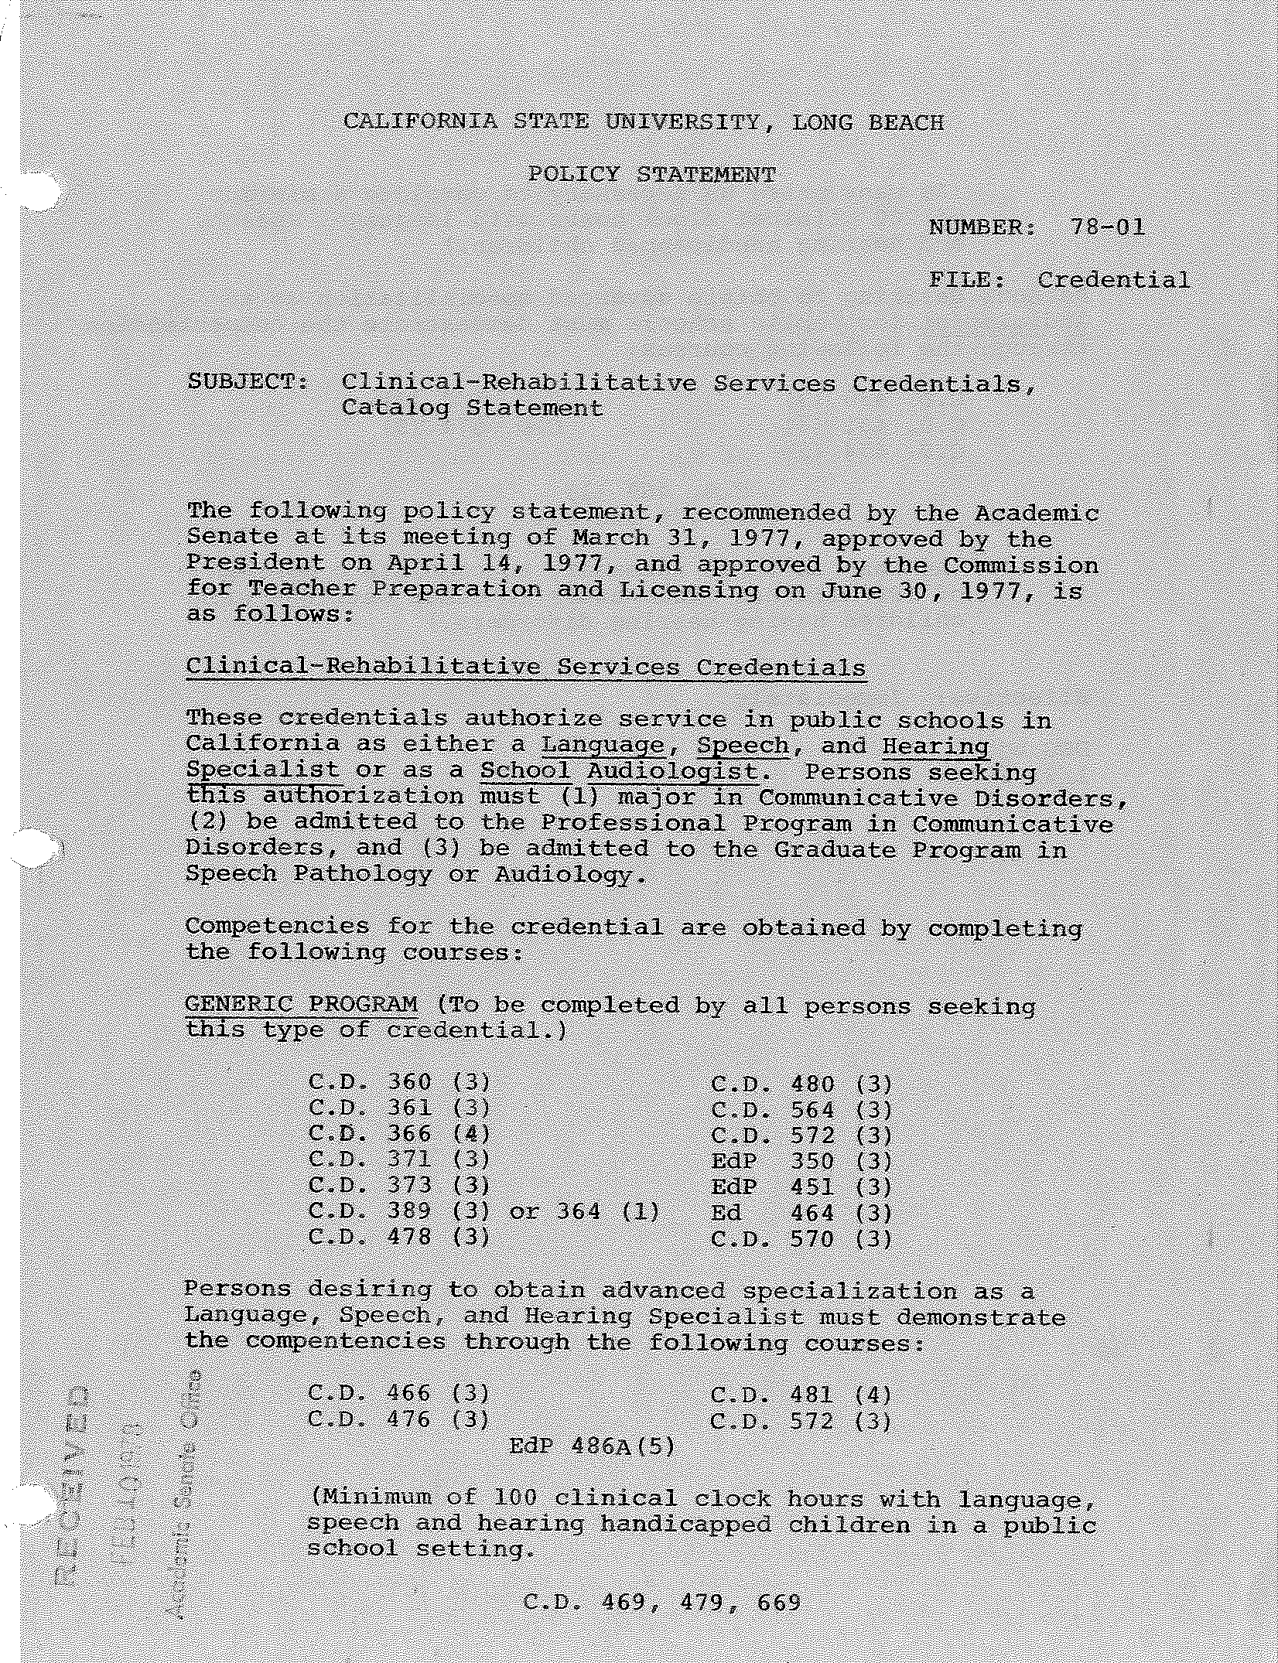

2-

and

units as necessary to a minimum
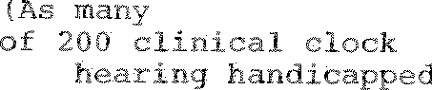
hours the language, speech, children.)

Persons Audiologist through the
to obtain for public schools following courses:
specialization as an

must demonstrate the competencies

C.D. 430 (3)
C.D. 431 (3)
C.D. 474 (3)

C.D. 469 (1)
C.D. 530 (3)
C.D. 574 (3)

C.D. 4 9 and 679

(As many units as necessary to complete a minimum of 100 clinical clock hours in other settings with children having hearing disorders.)

Effective: Immediately
DEG:bjp 1/23/78

\

