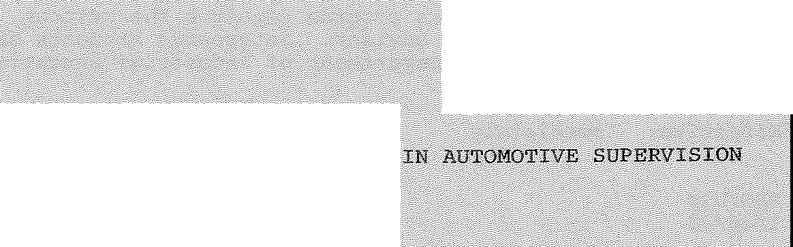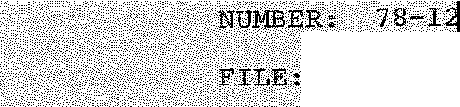C.A:Ll'FQRl5/IA .STATE IVERSIT;l., LONG BEACH
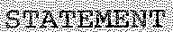

Sb:BJEC.11'; (';,ER.'l/IF:IC:l\.T:E P;ROGRAll:I
JUiIP $ERVICE

-<''-_-'-:<
Cel:tifici:lte

t;i,e··•ftil.lo :i.:n.\, polic:y..•·. tat,e ¢:rtt,...:rec0:1llllle deqif>t\tµe·.. t:i;i<lemfc
Se.n te qt. iJ;:s 111eeting. of .P'='ceJ:llbiiir J., 1177, q'(l.CL <3.:J;)!;)L'OVed. PY
tl)ce. l're13ide1Jot q!Jo Jaii.uarY 3? 11:l:Z:B, is ai;; folJ.qws.: .

CERTIFTCA':TIE. PROGAAM. IN· tl,.U'Ptl OTI S·UPERV:ISIO!.:f .AND S$RVIC.E
••....•.••...•1:11e.···p; J:i J at ··•Pro r•.in.·····Ai pmqtivei·$.11pe yisionanl'l
$e;t'l!'iG.e i.s designi:!d i::.{) preJ?ll.re i::uq.ents for•AuJ::qmqtive S.UJ?J=.ryis±:o.n; positions .tlt,:i.t r q;11ire 4 st:.:cong.•tecrmical, 1:/ackgrollml•:i.:'n a1.vt.Qil!Ql:)i]_e <!Qn,;.trµct;:i.:Q.!l a.!ld Qp!o!:r-a.tiQ.!l.
OppQ.rtu.nitie,;.••·in µt.oil!ot:i.:yl'!.Supe:cvisiqnan.q. .servip!o! ge frQII! )IlIDl!1 ac{tp.re:r·•.s cu.s:tomer IDl. l tecJ.:inic;al representative to s.erv:i.ce· i11strµctQr. ·

This 1nte:i;'d:i\Sqiplinary progr. :m pfov±d!c!s a sl.11dl'int "!ith qe!lth qf .t cnnlcql traini.ng in .a1.1to:moti'lles ,. re lated
a
teqj:nlical qourses, and .also p:coyide:s t;he 5tu<lent 'lfith e:!(p.ecriences f:n supervi.sf:011 necessary fp,r supervisory leve.1 positions. · ·
eg1.1it:.iment.s for the Ce±J::ificil"t.e ,in Aµto:mot±ve. Supervision:
- l.ii:iqheJ.Q.J;'S Degree in Ib.dµstrial :Arts .th<C1.t. incluo.es tl)ce followi.ng,

•1't... mir).inmm of 18 units Of automotive technical courses select:';'cl f:i:-om, .· I.A ;361,. '3(ijj 36,l,, :%5, '16:l.,. 462,
3:62, ·
.<j!>5 aJid, 492.. In ad.ditio.n tQce st.ucle!lt must.· comI)lete 2d>1.1n,it.s ·O.f s1.1pporting technical cqursefil and prpfef3sio11al courses chosen in 0011sultatiqnwith an acl,visor:
IA 321, 322, 32.3, 326, 33.I, 343, 370, 384, 470 and
EDSS 45(H.

- Tlle completion of t,l:1e following couri..eie fro1!J. tl)ce DeJ;??,rtment of IndusttJ,al ')'echnology, ;[.'J' 300, 307, 309, qr th.eir equivalent,

-2-

Any deviation from this program permission of the program advisor. contact Dr. Jay Webster, Department

requires the written Interested students should of Industrial Education.

Effective: Immediately

DEG:bjp 1/26/78

