Working Better: How to Use Your Email Effectively

GOOD (October 15, 2010)
http://www.good.is/post/working-better-how-to-use-your-email-effectively/
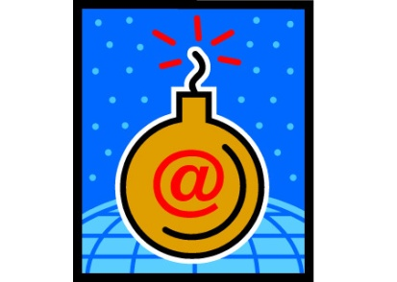
Chances are good that at some point, you’ve implemented some fancy email technique that you were certain could rid you of your chronic email anxiety via color-coded folders and an elaborate filtering system. You took the workshop or read the book, and then six weeks after it totally changed your life, you stopped doing it, only to find your inbox even messier than it was before. So what to do? Keep it simple. These strategies are tried and true—and easy as hell to keep up.
Embrace “Inbox Zero,” sometimes. The Inbox Zero model essentially says that an empty inbox is a happy inbox (and a happy you). It might not be practical for everyone to do every single day, but once a week, set aside an hour to make sure every email that demands your attention has received it. Once it’s done, file it away in a folder (something like “Old Mail”). It’s a great example of a little up-front work that makes your life so much easier in the long run.
For work emails, set a tone and keep it short. If you’re always really chatty in your emails, people will come to expect that from you and may be thrown off if, in a rush, you dash off something curt. Develop a consistent email personality for business correspondence that is polite, professional, and to the point—then stick to it.
Change your email settings. Tell Facebook & Twitter that you don’t want to get updates sent to your inbox.
Unsubscribe. It takes five seconds and clears the muck.
Check it less. Some productivity gurus advise us to check our email only twice or three times a day. If that seems unrealistic, how about once every hour instead of clicking every time you see the number go up on your inbox icon? Most things can wait at least that long.
Set up an auto reply. If you’re so backed up on email that it’s interfering with your work and offending people, you can let them know with a humble and honest auto reply that says as much. But do this very sparingly. Anyone who emails you more than once will get your bounce-back repeatedly, which can get annoying fast.
If you’re really hosed, declare email bankruptcy. This is a last resort—and a borderline obnoxious one. But if you’re so bogged down in email that you don’t know how to dig yourself out, this is an option. You simply tell every person in your inbox that you’ve deleted their email, and to please resend it if it’s important. It’s basically getting yourself to Inbox Zero without the work. Just make sure you keep up with the new messages.

