1. **Program Type**

* State-Support
* New Program

*The proposed minor in Supply Chain Management will utilize existing facilities and faculty. The only additional financial support will be state funding for additional student enrollment.*

1. **Program Identification**
   1. Campus: *California State University, Long Beach*
   2. Full and exact degree designation and title: *Minor in Supply Chain Management*
   3. Term and academic year of intended implementation: *Fall 2019*
   4. Name of the departments, division, or other unit of the campus that will offer the proposed minor. Please identify the unit that will have primary responsibility: *CBA Management & HRM Department; OSCM Faculty.*
   5. Name, title, and rank of the individual(s) primarily responsible for drafting the proposed minor: *Dr. Jessica L. Robinson, Assistant Professor of Supply Chain Management.*
   6. Statement from the appropriate campus administrative authority that the addition of this program supports the campus mission and will not impede the successful operation and growth of existing academic programs. *Please see attached letter of support from CBA Dean Michael Solt (Appendix A)*
   7. Any other campus approval documents that may apply (e.g. curriculum committee approvals). *See attached minutes from CBA Undergraduate Programs Committee.*
2. **Program Overview and Rationale**
   1. Rationale, including a brief description of the program, its purpose and strengths, fit with institutional mission, and justification for offering the program at this time. The rationale may explain relationships among the program philosophy, design, target population, and any distinctive pedagogical methods.

*Supply chain management is the systemic, strategic coordination of traditional business functions and decisions, within a focal firm and across supply chain member firms, with the purpose of improving the performance of the entire supply chain and individual firms. As such, the study of supply chain management is relevant to any organization that is part of a supply chain (i.e., involved in the forward and backward flows of products, services, information, and/or finances). Supply chain management encompasses all those activities associated with logistics management, product design, sourcing, procurement, sales and marketing, manufacturing operations, information technology, and finance. Accordingly, the target population includes undergraduate students in College of Arts (e.g., Industrial Design); College of Engineering (e.g., Aerospace, Civil, Mechanical); College of Health & Human Services (e.g., Fashion Merchandising, Hospitality Management, Recreation); College of Liberal Arts (e.g., Business Economics, Economics); and College of Natural Sciences and Mathematics (e.g., Applied Mathematics in Economics and Management, Applied Mathematics in Science and Engineering).*

* 1. Proposed catalog description, including program description, degree requirements, and admission requirements.

***Minor in Supply Chain Management***

*The minor in Supply Chain Management is designed to provide students with foundational training in the highly demanded area of modern supply chain management practices and in corresponding cross-functional skills that will advance student career prospects within a global supply chain environment. Students accepted for admission must have at least a 3.0 GPA with junior standing.*

* *The minor is comprised of six courses for a total of 18 units.*
* *For non-business students only, CBA students are not eligible.*
* *IS 301, which is required for all 400-level courses in CBA, is waived for minors.*
* *Students must take MGMT 300; SCM 410; SCM 411; SCM 414; and two electives from the following: MGMT 412; MGMT 413; MGMT 430; MGMT 456.*

1. **Curriculum** 
   1. These program proposal elements are required:

* Institutional learning outcomes (ILOs)
* Program learning outcomes (PLOs)
* Student learning outcomes (SLOs)

Describe outcomes (also known as goals) for (1) Institution, (2) Program, and (3) [Student Learning](http://www.calstate.edu/acadaff/sloa/index.shtml). Institutional learning outcomes (ILOs) typically highlight knowledge, skills, and dispositions all students are expected to have upon graduating from an institution of higher learning. Program learning outcomes (PLOs) highlight knowledge, skills, and dispositions students are expected to know as program graduates. The PLOs are more narrowly focused than ILOs. Student learning outcomes (SLOs) clearly convey the specific and measureable knowledge, skills, and/or behaviors that are expected and guide the type of assessments to be used to determine if the desired the level of learning has been achieved.

***Program Goals***

*This* *minor* *emphasizes* *student* *learning* *of* *supply* *chain management and related business functions* *with* *consideration to both practical and managerial skills. Coursework consists of developing non-CBA major’s knowledge on general business concepts and operations; specific functional business activities and practices; and integrative processes for supply chain management. The supply chain management minor will offer graduates significant opportunities for careers (e.g., increases placement options and salary) and growth (e.g., upward mobility and graduate school programs, including the MS-SCM at CSULB).*

***Institutional learning outcomes (ILOs)***

1. *Well-prepared in communication, numeracy and critical thinking skills to successfully join the workforce of California and the world or to pursue advanced study.*
2. *Critically and ethically engaged in global and local issues.*
3. *Knowledgeable and respectful of the diversity of individuals, groups, and cultures.*
4. *Accomplished at integrating the skills of a liberal education with disciplinary or professional competency.*
5. *Skilled in collaborative problem-solving, research, and creative activity.*

***Program Learning Outcomes (PLOs) and Student Learning Outcomes (SLOs)***

*Upon completion of the program, students will be expected to:*

1. *Critical Thinking. Students will be able to analyze, critique, and solve complex supply chain management problems that are associated with various functional conditions.*
2. *Ethics. Students will be familiar with dilemmas that supply chain managers encounter and will incorporate ethical, social responsibility, and citizenship considerations into their decision-making process.*
3. *Team & Interpersonal Skills. Students will be able to demonstrate interpersonal skills for the purpose of developing individual awareness and working in diverse teams.*
4. *Business Functions. Students will be knowledgeable on several business functions and will integrate functional understanding for conceptualizing supply chain management.*
5. *Quantitative & Technical Skills. Students will be able to execute both quantitative and technical skills to measure, evaluate, and improve firm and supply chain performance.*
6. *Domestic & Global Environment. Students will be informed of the domestic and global supply chain environments (e.g., legal, regulatory, political cultural, and economic).* 
   1. Plans for assessing program goals and student learning outcomes. Some planners find it helpful to develop matrices in which student learning outcomes and required courses are mapped, indicating where content related to learning outcomes is introduced, reinforced, and practiced at an advanced level in required courses (SLO description are given above).



The comprehensive assessment plan connecting ILOs, PLOs, and SLOs that are associated with the minor in Supply Chain Management is provided in the following table (page 4).



* 1. Total number of units required for the minor or certificate. *The minor requires 18 units.*
  2. A list of all courses required for the minor or certificate, specifying catalog number, title, units of credit, and prerequisites or co-requisites (i.e., ensuring that there are no “hidden” prerequisites that would drive total units required to graduate beyond the total reported in 4c above). *All courses must be completed with a grade of C or better. Please note that IS 301, which is required for all 400-level courses in CBA, is waived for minors.*

*Required Courses*

*MGMT 300: Principles of Management and Operations (3 Units)*

*SCM 410: Logistics Management (3 Units)*

*SCM 411: Operations Planning and Control (3 Units)*

*SCM 414: Supply Chain Management (3 Units)*

* 1. List of elective courses that can be used to satisfy requirements for the minor, specifying catalog number, title, units of credit, and prerequisites or co-requisites. Include proposed catalog descriptions of all new courses. *All courses must be completed with a grade of C or better. IS 301, which is required for all 400-level courses in CBA is waived for minors.*

*Elective Courses*

*MGMT 412: Production Control (3 Units)*

*MGMT 413: Managing Quality Productivity (3 Units)*

*MGMT 430: Project Management (3 Units)*

*MGMT 456: Service Management (3 Units)*

* 1. List of any new courses that are: (1) needed to initiate the program and (2) needed during the first two years after the implementation. *No new courses will be needed to initiate the program or be necessary in subsequent years.*
  2. Attach a proposed course-offering plan for first three years of program implementation, indicating, where possible, likely faculty teaching assignments.

*Multiple sections of MGMT 300 are offered every semester (8-10 sections) with open seats in three sections in both semesters of the 2016-2017 schedule of classes. Three sections of SCM 410 are offered in the fall and two sections are offered in the spring (open seats). Two sections are offered in the fall and spring semesters for both SCM 411 and SCM 414 (open seats). One section of MGMT 412 is offered during the spring semester (open seats) and one section of MGMT 413 is offered for the fall and spring semesters. One section of MGMT 430 is offered in the fall and two sections are offered in the spring semester (open seats). Two sections of MGMT 456 are offered in the fall semester. Likely assignments:*



1. Admission criteria, including prerequisite coursework. *Must be a current undergraduate student at CSULB with junior standing (CBA students are not eligible for this program)*
2. Criteria for student continuation in the program. *C grades or better in all courses taken.*
3. Provision for meeting accreditation requirements, if applicable, and anticipated date of accreditation request (including the WASC Substantive Change process). *N/A*
4. **Need for the Proposed Minor or Certificate Program** 
   1. List of other CSU campuses currently offering or projecting the proposed programs; list of neighboring institutions, public and private, currently offering the proposed programs.

*Among the 23 CSU campuses, CSU Chico, Cal Poly Pomona, CSU Los Angeles, and CSU San Bernardino have a minor in Supply Chain Management (or equivalent). In addition, University of Southern California and University of San Diego also have OSCM minors. None of the following research or private universities have a Supply Chain Management (or equivalent) minor: Loyola Marymount, UC Irvine, Pepperdine, Claremont Colleges.*

* 1. Differences between the proposed program and programs listed in Section 5a above.

*CSU Chico Operations Supply Chain Management minor requires 18 units (4 required courses; 2 selected courses). Open to non-business and business majors.*

*Cal Poly Pomona Operations Management minor requires 24 units (3 requisite courses; 4 required courses; 2 selected courses). Open to non-business and business majors.*

*CSU Los Angeles Operations Supply Chain Management minor requires 15 units (3 required courses; 2 selected courses). Open to non-business majors.*

*CSU San Bernardino Supply Chain Management minor requires 28 units (7 required courses). Open to non-business and business majors.*

*University of Southern California Operations Supply Chain Management minor requires 20 units (3 required courses; 2 selected courses). Open to non-business majors.*

*University of San Diego Supply Chain Management minor requires 18 units (5 required courses; 1 selected course). Open to non-business and business majors.*

*The proposed CSULB minor program in Supply Chain Management is 18 semester units (4 required courses; two electives from four options) and is exclusively for non-business majors. CSULB management major students who would like further instruction in Supply Chain Management are encouraged to double-major.*

* 1. List of curricula currently offered by campus that are closely related to proposed program.

*None of the current or proposed CBA minors are closely related to the proposed minor in supply chain management (e.g., no SCM courses are listed as a requirement or an elective in any of the six CBA minors). Outside of CBA, CLA offers a minor in Economics. Students are required to take four electives in which among the 37 potential courses, two are titled ECON 420: Forecasting and ECON 455: Transportation Economics. Although these two courses may seem to overlap with two of the minor required courses (Operations Planning & Control; Logistics Management), as shown, the catalog descriptions indicate otherwise:*

* *Forecasting (ECON 420): Forecasting principles and methods. Evaluation of reliability of existing forecasting techniques. Also covers use of macroeconomic model as a basis for forecasting and the role of forecasts in the formulation of national economic policy.*
* *Transportation Economics (ECON 455): Economic analysis of intercity transportation, cost measurement, applications of pricing principles, project evaluation, and economic regulation. Policies towards railroads, air transportation, and intercity highways.*
  1. Community participation, if any, in the planning process. This may include prospective employers of graduates. *No community participation is required.*
  2. Applicable workforce demand projections and other relevant data.

*The San Pedro Bay Port Complex (LA/LB) is responsible for approximately 186,000 jobs in LA/LB (1 in 12); 976,000 jobs in the five-county SoCal region (1 in 9); and 2.8 million jobs throughout the US (Facts and Figures, 2017). According to the US Bureau of Labor Statistics (2016), Transportation & Material Moving (7.2%) and Production (6.5%) are 4th and 5th most common occupational groups in the Los Angeles-Long Beach-Glendale Metropolitan Division. Transportation, Storage, and Distribution Managers (4,480) and Purchasing* *Managers* *(2,440)* *career* *titles* *are* *both* *higher* *than the national occupational employment average. CA.Gov also estimates employment in the same region during 2017: Transportation, Warehousing, & Utilities (180,300); Warehousing and Storage (17,400).*

*Sources:*

*Facts and Figures (2017). https://www.portoflosangeles.org/about/facts.asp*

*US Bureau of Labor Statistics (2016). https://www.bls.gov/regions/west/news-release/occupationalemploymentandwages_losangeles.htm*

*CA.Gov (2017). https://data.edd.ca.gov/Industry-Information-/Industry-Employment-in-California-Metropolitan-Are/kvqr-r7dx*

* 1. If the program was proposed to meet society’s need for the advancement of knowledge, please specify the need and explain how the program meets that need.

*The primary purpose of this program is to improve employment opportunities of CSULB graduates. However, as shown in the above workforce demand projections, our students will be contributing to the major economic driver of Long Beach and surrounding cities.*

1. **Student Demand** 
   1. Compelling evidence of student interest in enrolling in the proposed program. Types of evidence vary and may include national, statewide, and professional employment forecasts and surveys; petitions; lists of related associate degree programs at feeder community colleges; reports from community college transfer centers; and enrollments from feeder baccalaureate programs, for example.

*The* *Operations* *&* *Supply* *Chain* *Management* *major* *had* *165* *students* *in* *2016,* *139* *in* *2015, 121 in 2014, and 138 in 2013. There are 114 students enrolled for fall 2017 (as of 5/9/17).*

*A student survey was administered to capture student demand (Spring, 2017). Department chairs from targeted* *majors* *disseminated* *the* *survey (n = 79). (For targeted majors, please see p. 1, item 3.a). Of these 79 respondents, 36 students indicated they would “likely” enroll in the proposed minor if offered immediately (AY 2016-2017) and 19 indicated interest in the following AY (2018-2019). The numbers do not control for GPA (some may disqualify – see estimates shown under 6.d). Overall, there appears to be significant interest across the campus. Student comments are below:*

*“Allows for more advancement without adding too much into my current academic goals.”*

*“Growing field with many positions open and a general interested in the subject matter.”*

*“We need to have basic knowledge of how things we create are managed.”*

*“It would go well with my major, plus I am in need of a minor.”*

*“I was considering of applying to the supply chain masters program, but wanted to take*

*some classes to see what it involved.”*

*“I’m interested in learning about logistics because I understand the importance of it.”*

* 1. Issues of access considered when planning this program.
* Course scheduling for students and qualified faculty

*Multiple sections of MGMT 300 are offered every year (8-10 sections per semester), five sections of SCM 410 are offered every year (2-3 sections per semester), four sections of both SCM 411 and SCM 414 are offered every year (2 sections per semester), one section of MGMT 412 is offered every year (during spring semester), two sections of both MGMT 413 and MGMT 456 are offered every year (1 section per semester), and three sections of MGMT 430 is offered every year (1-2 sections per semester). All courses have open seats.*

* Student financial aid

*The usual financial aid will be applicable.*

* Program funding for student scholarships

*If the program is approved, we can work to include minors in the SCM scholarship that is currently open only to SCM majors (Josh Owen Scholarship). There are also several CBA scholarships (e.g., Boeing, Ford, Knott’s, LBSNY Club, Meta Bergin, Holmes, and CBA).*

* Student Recruitment

*The CBA Center for Student Success has an Outreach Coordinator that actively promotes programs offered by CBA. Dr. Jessica Robinson will serve as the minor faculty advisor.*

* 1. Professional uses of the proposed program.

*The proposed minor in Supply Chain Management enhances employment opportunities. A supply chain refers to, “A set of three or more entities (organizations or individuals) directly involved in the upstream and downstream flows of products, services, finances, and/or information from a source to a customer,” (Mentzer et al., 2001, p. 4). Therefore, most, if not all, companies are in at least one supply chain. Career fields and positions in SCM, which are facilitated by the proposed minor, generally entail (small representation):*

* *Demand Forecasting*
* *Distribution Management*
* *Export/Import Operations*
* *Industrial Packaging*
* *Inventory Management*
* *Logistics Management*
* *Materials/Production Planning*
* *Negotiation/Partner Management*
* *Procurement/Supply Management*
* *Supply Chain Data Analytics*
* *Warehouse/Facility Management*
* *Equipment/Facilities Manager*
* *Inventory Control Manager*
* *Logistics Engineer*
* *Transportation Manager*
* *Process Engineer*
* *Production Manager*
* *Project Manager*
* *Supply Chain Analyst/Manager*
* *Supply Chain Consultant*
* *Vendor Managed Inventory Coordinator*
* *Warehouse Operations Manager*
  1. Expected number of students in the year of initiation, three years, and five years thereafter. *Included in the student survey that was administered to capture student demand (Spring, 2017), was an intention question for enrolling in the minor. Based on the data, the below figures were estimated (2016-2017; 2017-2018; 2018-2019; Unlikely; Not Sure; Likely):*

*Year of Initiation – up to 15 students*

*Three Years – 15-20 students*

*Five years – 20-25 students*

1. **Existing Support Resources for the Proposed Minor or Certificate Program**

**Note:** Sections 7 and 8 should be prepared in consultation with campus administrators responsible for faculty staffing and instructional facilities allocation and planning. A statement from responsible administrator(s) should be attached to the proposal assuring that such consultation has taken place.

1. Faculty who would teach in the program, indicating rank, appointment status, highest degree earned, date and field of highest degree, professional experience, and affiliations with other campus programs. *The CBA courses in this minor are part of regular course offerings. Four SCM faculty, several management faculty, and several instructors are available to teach. See table in section 4g (likely faculty teaching assignments – 3 years).*
2. Space and facilitiesthat would be used in support of the proposed program.

*Current facilities would be used:*

* *CBA Classrooms*
* *CBA Computer Classrooms*
* *CBA Open Access Lab*

c. A report provided by the campus Library, detailing resources available to support the program (discussion of subject areas, volume counts, periodical holdings, etc. are appropriate). *Please see attached report from Susan Jackson (Appendix B)*

d. Existing academic technology, equipment, and other specialized materials currently available. *The current academic technology is sufficient. No specialized equipment or materials needed.*

1. **Additional Support Resources Required**
2. Any special characteristics of the additional faculty or staff support positions needed to implement the proposed program. *Existing faculty/staff and resources are sufficient to meet the needs of the program. No additional resources will be allocated to the minor.*
3. The amount of additional lecture and/or laboratory space required to initiate and to sustain the program over the next five years. Indicate any additional special facilities that will be required. If the space is under construction, what is the projected occupancy date? If the space is planned, indicate campus-wide priority of the facility, capital outlay program priority, and projected date of occupancy. *No additional lecture or laboratory space is required.*  *Existing classrooms, laboratory facilities, and technology are sufficient to initiate and sustain program over next five years.*
4. A report written in consultation with the campus librarian, indicating any additional library resources needed. Indicate the commitment of the campus either to purchase or borrow through interlibrary loan these additional resources. *Current library resources are considered sufficient. Additional resources, if needed, are readily available through interlibrary loans.*
5. Additional academic technology, equipment, or specialized materials that will be (1) needed to implement the program and (2) needed during the first two years after initiation. Indicate source of funds and priority to secure these resource needs.*Current technology, equipment, and databases are sufficient to implement and sustain program for two years.*

**Appendix A**

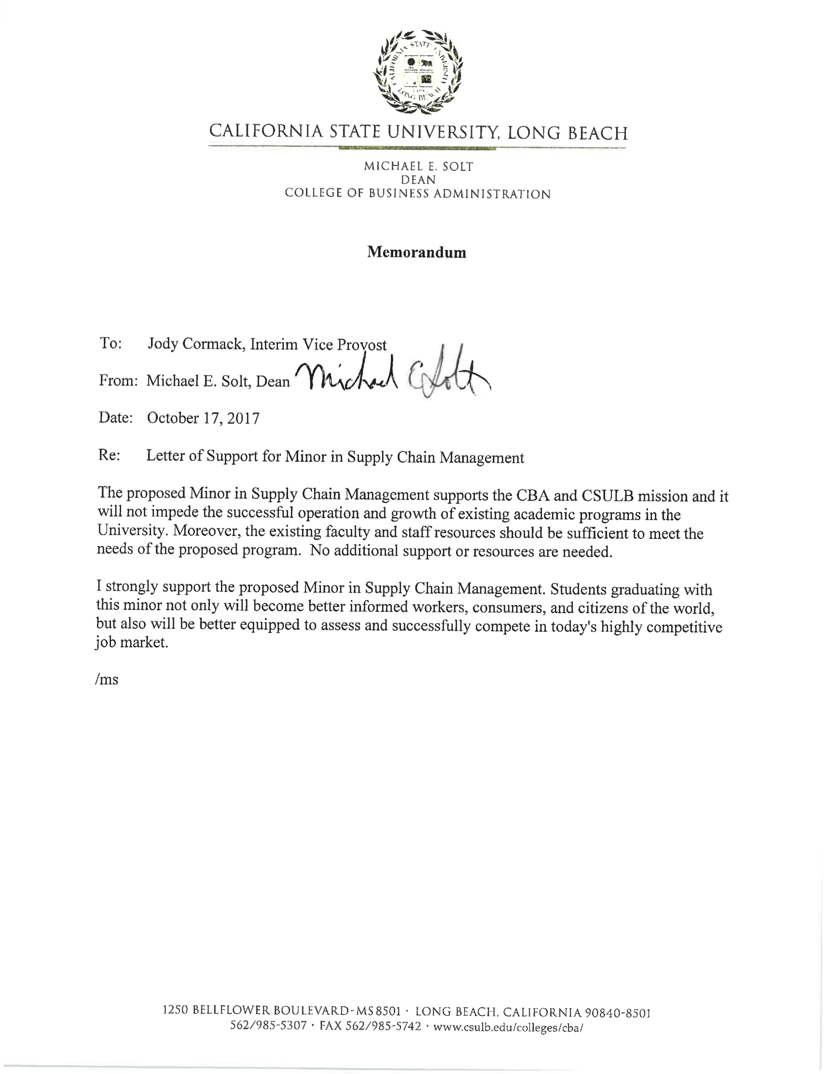

**Appendix B**

**Assessment of Additional Library Resources Needed to Support Proposed Programs**

**Name of Proposed Program ______Minor in Supply Chain Management_____________________**

**Department ____Management_& HRM________________________________________________**

**Assessed by (library faculty member) _____Susan B. Jackson_______________________________**

**Date _________12/19/17_________________**

*Following is a template for assessing additional Library resources needed to support proposed program. The new program proposal process requires assessments of additional resources needed, including library resources. While departments/programs may believe the Library has sufficient resources, it is the Library Faculty member for the relevant department/program, in collaboration with the department/program, who has responsibility for this assessment. The Library’s collection development officer will assist where needed, and should review assessments where new resources are deemed necessary.*

*A shorter assessment may be sufficient for new minors in programs where the librarian and the department believe there are sufficient library resources.*

1. Department faculty and library faculty jointly identify key journals needed by students and faculty in the program, noting those for which ILL options are sufficient, and those needed in house or online.
   1. Department faculty identify journals they see as key to program success.

* **Journal of Supply Chain Management: available through the Library**
* **Journal of Operations Management: available through the Library**
* **Journal of Business Logistics: available through the Library but embargo on the current year**
* **International Journal of Physical Distribution & Logistics Management: available through the Library**
* **International Journal of Logistics Management: available through the Library**
  1. Library faculty may suggest other titles including:
     1. Journals in the field with high impact factors
     2. Journals appearing in surveys or literature reviews that are highly rated by that discipline’s faculty.
     3. Journals in the field with high numbers of interlibrary loan requests
  2. For each ***new*** journal title, the librarian will determine:
     1. The subscription cost
     2. What has interlibrary loan demand been over past two years?

1. Identify new/other databases key to program success.
   1. Library faculty will identify suggested additional relevant databases. Department faculty may want to suggest other databases.

**One database that has recently been brought to the business librarian’s attention is IBISWorld’s Procurement Reports**

* 1. For any ***new*** databases, library faculty will identify cost. **IBISWorld’s Procurement Reports would cost $4,950.00 (price quoted December 2017).**

1. Identify other additional print and online resources (e.g. eBooks, streaming video, maps, digital collections/institutional repository access) that are key to program success. For each resource identified by Library or departmental faculty, Library faculty will include resource costs.
2. Librarian-led research instruction:
   1. What is anticipated additional Library faculty instructional demand? **No additional instruction will be required**
   2. If this is a graduate program, are there potential additional library instructional or one-on-one consultation needs anticipated?
   3. Can anticipated instructional demand be accommodated with existing Library faculty?
3. How will additional resources be funded? Additional campus funding to library? Absorbed by current Library budget? An ongoing contribution from the proposing department? Outside funding? **No additional funding will be required.**

**If any additional resources were needed, the Library, at this time, could not increase the materials budget for the College of Business. Any new resources for the program would have to be financed by a source outside of the Library.**

**NOTE: This program is a minor of a course of study that already exists in the College of Business. It will require no additional classes or resources.**