From: The Executive Committee of the Academic Senate
To: The Academic Senate
Roman Kochan, Dean, University Library, CSULB
Date: September 11, 2018
Re: Dissolution of University Library Committee

To whom it may concern:

The Executive Committee of the Academic Senate hereby proposes the dissolution of the University Library Committee.

Last year, the EC was advised of the moribund status of this committee: It no longer fulfilled its charge to support and advocate a fundamental role for the library in the intellectual life of the University and work to ensure that library services and collections meet the teaching, research and lifelong learning needs of the University community, as well as to promote collaboration and communication between the library faculty and the teaching faculty to integrate information competence into the curriculum, including consulting the Faculty Advisory Council on Technology (see Charge at http://web.csulb.edu/divisions/aa/grad_undergrad/senate/ committees/ulc/charge/).

In response, the EC suspended the work of the committee. Since then, the work of this committee and the items addressed in the charge have been taken up by other groups and individuals such as Dean Kochan, and no requests have come to the Academic Senate to revive the committee.

For that reason, the EC recommends that the Academic Senate dissolve the University Library Committee. Instead, we request that the Dean of the University Library give a report on the status of the University Library to the Academic Senate at least once a year starting in the academic year 2018/19, and that such a report be written into any future position description for a Dean of the University Library.

Sincerely,
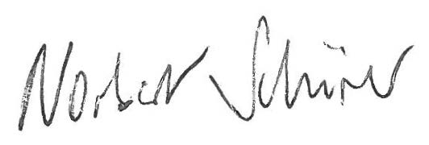
Norbert Schürer
Chair, Academic Senate

