From: The Executive Committee of the Academic Senate
To: The Academic Senate
Date: September 11, 2018
Re: Dissolution of Educator Preparation Committee

To whom it may concern:

The Executive Committee (EC) of the Academic Senate hereby proposes the dissolution of the Educator Preparation Committee.

Last year, the EC was advised of the moribund status of this committee: It no longer fulfilled its charge to advocate for educator preparation across the university; advise and make recommendations to CEPC and the Academic Senate regarding proposals or policies related to educator preparation across campus; and advise CEPC, the Academic Senate; and the ASCSU on contemporary local, state, and national education initiatives, policies, reforms, and issues (see Charge at http://web.csulb.edu/divisions/aa/grad_undergrad/senate/committees/tpc/).

In response, the EC suspended the work of the committee. Since then, the work of this committee and the items addressed in the charge have been taken up by other individuals and groups, and no requests have come to the Academic Senate to revive the committee.

For that reason, the EC recommends that the Academic Senate dissolve the Educator Preparation Committee.

Sincerely,
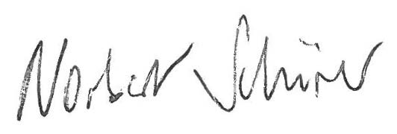
Norbert Schürer
Chair, Academic Senate

