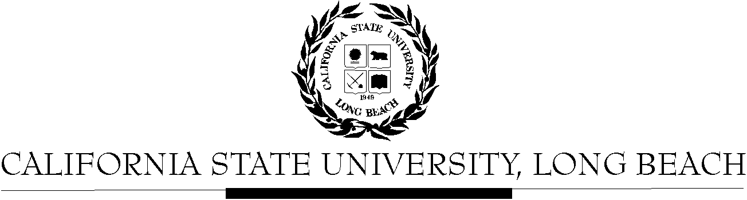

General Education Governing Committee

Agenda
January 25, 2016
2:00pm – 4:00pm – President’s Office, Conference Room, BH-302

Please notify a member of the GEGC Executive Committee (Heather.Rae-Espinoza@csulb.edu, Danny.Paskin@csulb.edu, Grace.Reynolds@csulb.edu or Vanessa.Red@csulb.edu) if you are unable to attend.

- Call to Order

- Approval of Agenda

- Approval of Minutes: GEGC Minutes posted on BeachBoard

- Announcements
  - No updates from the following tabled courses: AIS/FEA 450, A/ST 315, ART 101 or 121

- Tabled Courses
    - AIS/FEA 450: American Indian and Indigenous Cinema – Tabled on 10/12/15
      - Posted on BeachBoard/GE Course Proposals Fall 2015, AY 2015-2016
      - New to General Education
      - Request for Explorations: The Arts; Human Diversity
      - Discussion:
        - Concerns about the human diversity representation between the comparative aspect of American Indians and Pacific Islanders as well as in the title.
        - There are also concerns about gender and the one additional component. They did put the policy within the SCO, but it was hard to see within the outline of the course. They should integrate other signs of gender and an additional marker into the course.
        - Suggest that the department add Information Literacy as a secondary skill to the course because it is strong in media literacy.
      - Motion to table to include revisions with the inclusion of gender and one additional component to better align with the Human Diversity policy – approved w/ 1 abstention
    - A/ST 315: Modern Korea – Tabled on 10/26/15
      - Posted on BeachBoard/GE Course Proposals Fall 2015, AY 2015-2016
      - New to General Education
      - Request for Explorations: Social Sciences & Citizenship; Global Issues
      - Discussion:
        - The department checked interdisciplinary as the essential skill, but then discussed integrative learning in the SCO.
        - The justification blurb in the beginning needs to be more developed.
        - Should move the prerequisites description into the catalog description section.
        - The committee is concerned whether the course meets the Global Issues criteria due to only examining North and South Korea. According to the policy, they do meet the “significantly distinct societies”.
        - It seems the department used the student side description for essential skills instead of the faculty links for the description.
      - Recommendations: Change the integrative learning essential skill (objective 1) to match the interdisciplinary essential skill checked; update catalog description to include prerequisites; update objective 2 to include the global learning descriptions
      - Motion to table
    - ART 101: Artists in their Own Words – Tabled on 12/14/15
      - Posted on BeachBoard/GE Course Proposals Fall 2015, AY 2015-2016
      - New to General Education
      - Request for Explorations: Lifelong Learning & Self Development
      - Discussion:
        - Need to update prerequisites to include one or more foundation courses.
        - Question about students being able to take this course more than once as it is a repeatable course up to 3 units. Need to clarify whether a student would be able to take this course multiple times to fulfil the designation.
        - The committee feels that this course is very specific to majors and is not necessarily for other students outside the major.
        - The committee is recommending that the department might want to consider a 200 level designation.
      - Motion to table – approved with 1 abstention
    - ART 121: Safety and Sustainable Practices – Tabled on 12/14/15
      - Posted on BeachBoard/GE Course Proposals Fall 2015, AY 2015-2016
      - New to General Education
      - Request for Explorations: Lifelong Learning & Self Development
      - Discussion:
        - Prerequisite needs to include one foundation or more.
        - The committee member feels that the creativity and discovery essential skill is not as evident in the course. There is underlying text within the SCO that shows they are being creative. They need to revise the language to make it more clear that there is creativity within the course.
        - Some committee members would like to have more explanation of the parenthetical essential skills within the measurable outcomes.
      - Motion to table – approved with one abstention

- Course Reviews
  - Old Business
    - HIST 463/IST 476: Power and Violence in Latin America and the Caribbean – Removed from agenda on 9/28/15
      - Posted on BeachBoard/GE Course Proposals Fall 2015, AY 2015-2016
      - New to General Education
      - Request for Capstone: Interdisciplinary, Writing Intensive
      - Discussion:
        - Check mark should be changed and is missing required primary skill.
      - MOVED to remove from agenda – Unanimously approved
  - New Business
    - CWL 132: World Mythology
      - Posted on BeachBoard/GE Course Proposals Fall 2015, AY 2015-2016
      - Existing to General Education
      - Request to continue Explorations: Humanities-Literature
      - Request to add Global Issues
    - FEA 486: Alternative Media
      - Posted on BeachBoard/GE Course Proposals Fall 2015, AY 2015-2016
      - Existing to General Education
      - Request to continue Capstone: Interdisciplinary; Other Humanities
      - Request to add Capstone: Writing Intensive
    - FSCI 101: Franken Food: Fact or Science Fiction
      - Posted on BeachBoard/GE Course Proposals Fall 2015, AY 2015-2016
      - New to General Education
      - Request for Foundation: Written Communication
    - PHIL 382: Theory of Knowledge
      - Posted on BeachBoard/GE Course Proposals Fall 2015, AY 2015-2016
      - New to General Education
      - Request for Capstone: Writing Intensive; Humanities: Philosophy
    - POSC 401/WGSS 402: Women in Political Theory
      - Posted on BeachBoard/GE Course Proposals Fall 2015, AY 2015-2016
      - New to General Education
      - Request for Capstone: Writing Intensive
    - CLA/HHS 296: Introduction to (Behavioral) Research Methods
      - Posted on BeachBoard/GE Course Proposals Fall 2015, AY 2015-2016
      - New to General Education
      - Request for Explorations: Life Sciences No Lab
    - CHLS 360: Chicana/o and Latina/o Rhetoric
      - Posted on BeachBoard/GE Course Proposals Fall 2015, AY 2015-2016
      - New to General Education
      - Request for Capstone: Writing Intensive
    - CLA/HHS 496: Advanced Research Methods
      - Posted on BeachBoard/GE Course Proposals Fall 2015, AY 2015-2016
      - New to General Education
      - Request for Capstone: Advanced Skills
    - FIL 201: Intermediate Filipino
      - Posted on BeachBoard/GE Course Proposals Fall 2015, AY 2015-2016
      - New to General Education
      - Request for Explorations: Humanities-Foreign Language
    - FIL 202: Intermediate Filipino
      - Posted on BeachBoard/GE Course Proposals Fall 2015, AY 2015-2016
      - New to General Education
      - Request for Explorations: Humanities-Foreign Language
    - CLA/HHS/ENGR/NSCI 361: Scientific Research Communication
      - Posted on BeachBoard/GE Course Proposals Fall 2015, AY 2015-2016
      - New to General Education
      - Request for Capstone: Writing Intensive
    - ENGR/NSCI 296: Introduction to Biomedical Research Methods
      - Posted on BeachBoard/GE Course Proposals Fall 2015, AY 2015-2016
      - New to General Education
      - Request for Explorations: Life Sciences No Lab
    - ENGR/NSCI 496: Advanced Biomedical Research Methods
      - Posted on BeachBoard/GE Course Proposals Fall 2015, AY 2015-2016
      - New to General Education
      - Request for Capstone: Advanced Skills
- Adjournment

- Future Agenda/Discussion Items

