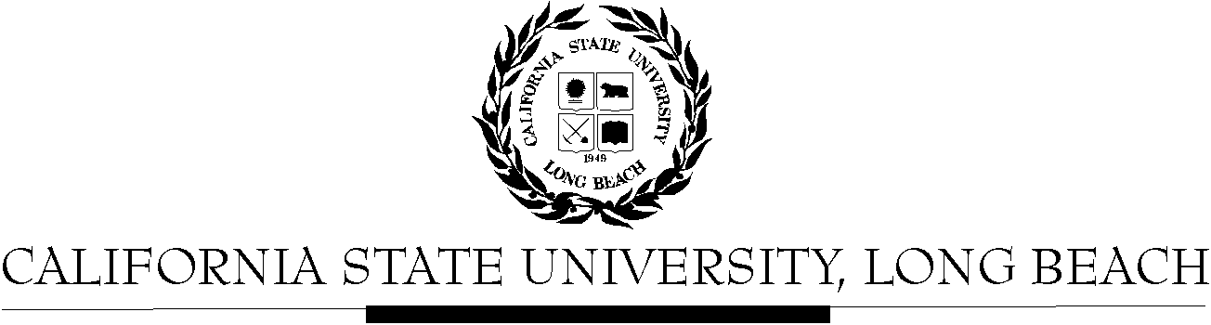

General Education Governing Committee

Agenda
March 14, 2016
2:00pm – 4:00pm – President’s Office, Conference Room, BH-302

Please notify a member of the GEGC Executive Committee (Heather.Rae-Espinoza@csulb.edu, Danny.Paskin@csulb.edu, Grace.Reynolds@csulb.edu or Vanessa.Red@csulb.edu) if you are unable to attend.

- Call to Order

- Approval of Agenda

- Approval of Minutes: GEGC Minutes posted on BeachBoard

- Announcements
  - No updates from the following tabled courses: AIS/FEA 450, A/ST 315, CLA/HHS 296, ENGR/NSCI 296

- GE Status Reports
  - Update from Mary McPherson on GE Report
  - Proposal to add Information Literacy to Advanced Skills Category

- Tabled Courses
    - AIS/FEA 450: American Indian and Indigenous Cinema – Tabled on 10/12/15 – No updates available
      - Posted on BeachBoard/GE Course Proposals Fall 2015, AY 2015-2016
      - New to General Education
      - Request for Explorations: The Arts; Human Diversity
      - Discussion:
        - Concerns about the human diversity representation between the comparative aspect of American Indians and Pacific Islanders as well as in the title.
        - There are also concerns about gender and the one additional component. They did put the policy within the SCO, but it was hard to see within the outline of the course. They should integrate other signs of gender and an additional marker into the course.
        - Suggest that the department add Information Literacy as a secondary skill to the course because it is strong in media literacy.
      - Motion to table to include revisions with the inclusion of gender and one additional component to better align with the Human Diversity policy – approved w/ 1 abstention
    - A/ST 315: Modern Korea – Tabled on 10/26/15 – No updates available
      - Posted on BeachBoard/GE Course Proposals Fall 2015, AY 2015-2016
      - New to General Education
      - Request for Explorations: Social Sciences & Citizenship; Global Issues
      - Discussion:
        - The department checked interdisciplinary as the essential skill, but then discussed integrative learning in the SCO.
        - The justification blurb in the beginning needs to be more developed.
        - Should move the prerequisites description into the catalog description section.
        - The committee is concerned whether the course meets the Global Issues criteria due to only examining North and South Korea. According to the policy, they do meet the “significantly distinct societies”.
        - It seems the department used the student side description for essential skills instead of the faculty links for the description.
      - Recommendations: Change the integrative learning essential skill (objective 1) to match the interdisciplinary essential skill checked; update catalog description to include prerequisites; update objective 2 to include the global learning descriptions
      - Motion to table
    - CLA/HHS 296: Introduction to (Behavioral) Research Methods -Tabled on 1/25/16 – No updates available
      - Posted on BeachBoard/GE Course Proposals Fall 2015, AY 2015-2016
      - New to General Education
      - Request for Explorations: Life Sciences No Lab
      - Discussion:
        - There is an issue with the prerequisite being “GE foundations or Consent of Instructor”. The issue is with instructor consent. The course cannot have instructor consent as an exploration course.
        - The committee feels that the department is using the course to teach the methodology but not necessarily the life sciences portion. The committee would like to see more clarification that it is a life science.
        - Committee member would like to see foundations of living and non-living systems.
        - Recommendations: list of topics connecting the course to life science
      - Motion to table – unanimously approved
    - ENGR/NSCI 296: Introduction to Biomedical Research Methods - Tabled 2/8/16 – No updates available
      - Posted on BeachBoard/GE Course Proposals Fall 2015, AY 2015-2016
      - New to General Education
      - Request for Explorations: Life Sciences No Lab
      - Discussion:
        - Committee members feel like there is no biology in this course and it does not meet the GE category.
        - Some concerns include the course being built specifically for BUILD program students even though this is a GE course for all students. Other concerns include enrollment management for the BUILD students, the course being a research method course instead of a science course.
        - A suggestion from the committee is to think about making this course a critical thinking course. The committee also feels that the department should speak with Mary McPherson (GE coordinator) to get the course sorted out in the correct category.
      - Motion to table to speak with GE coordinator and Honors program for clarification – unanimously approved
    - CLA/HHS 496: Advanced Research Methods- Tabled 2/8/16 – Updates available on BeachBoard
      - Posted on BeachBoard/GE Course Proposals Fall 2015, AY 2015-2016
      - New to General Education
      - Request for Capstone: Advanced Skills
      - Discussion:
        - Concerns include: no catalog description, word count verification of 2500 words, early feedback, typo on perquisites (should be 361 not 362), lecture notes issue, essential skills, weekly breakdown (would like to see one).
        - Committee member concern with the department chose written communication as an essential skill but in the SCO they discuss oral communication and do not have as much writing.
        - Justification says that Written Communication is a secondary skill, but they chose it as a primary skill on the GEAR form.
        - Committee member feels that the Inquiry and Analysis explanation is not specific enough due to assignments varying by instructor. Should be more specific.
      - Motion to table – unanimously approved
    - ENGR/NSCI 496: Advanced Biomedical Research Methods - Tabled 2/8/16 – Updates available on BeachBoard
      - Posted on BeachBoard/GE Course Proposals Fall 2015, AY 2015-2016
      - New to General Education
      - Request for Capstone: Advanced Skills
      - Discussion:
        - Same issues as CLA/HHS 496

- Course Reviews
  - New Business
    - UNIV 150: Research Career Exploration in Sciences
      - Posted on BeachBoard/GE Course Proposals Fall 2015, AY 2015-2016
      - New to General Education
      - Request for Explorations: Lifelong Learning and Self Development
    - HHS 207: Interdisciplinary Approaches to Health Disparities
      - Posted on BeachBoard/GE Course Proposals Fall 2015, AY 2015-2016
      - New to General Education
      - Request for Explorations: Social Sciences & Citizenship; Human Diversity
- Adjournment

- Future Agenda/Discussion Items

