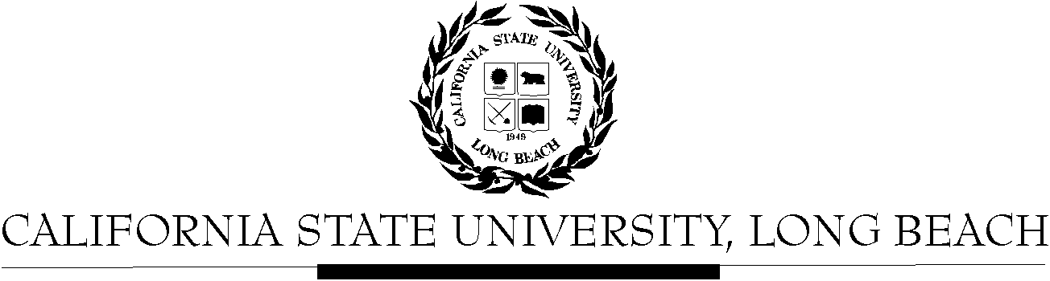

General Education Governing Committee

Agenda
December 14, 2015
2:00pm – 4:00pm – Academic Senate, Conference Room, AS-125

Please notify a member of the GEGC Executive Committee (Heather.Rae-Espinoza@csulb.edu, Danny.Paskin@csulb.edu, Grace.Reynolds@csulb.edu or Vanessa.Red@csulb.edu) if you are unable to attend.

- Call to Order

- Approval of Agenda

- Approval of Minutes: GEGC Minutes posted on BeachBoard

- Announcements
  - No updates from the following tabled courses: AIS/FEA 450 and AST 315.

- Course Reviews
  - New Business
    - GERN 400
      - Posted on BeachBoard/GE Course Proposals Fall 2015, AY 2015-2016
      - Existing to General Education
      - Request to continue Capstone: Interdisciplinary; Human Diversity
      - Request to add Capstone: Writing Intensive
    - AIS 454: Contemporary Arts Indigenous in the US and American Territories
      - Posted on BeachBoard/GE Course Proposals Fall 2015, AY 2015-2016
      - New to General Education
      - Request for Explorations: The Arts; Human Diversity
    - AH 432: Museum and Gallery Practices
      - Posted on BeachBoard/GE Course Proposals Fall 2015, AY 2015-2016
      - New to General Education
      - Request for Capstone: Advanced Skills, Writing Intensive
    - AH 433: Exhibition and Display Practices
      - Posted on BeachBoard/GE Course Proposals Fall 2015, AY 2015-2016
      - New to General Education
      - Request for Capstone: Advanced Skills
    - AH 446: Art History Methodologies & Writing
      - Posted on BeachBoard/GE Course Proposals Fall 2015, AY 2015-2016
      - New to General Education
      - Request for Capstone: Interdisciplinary, Writing Intensive, Integrative Learning
    - AH 453: The Arts of the African Diaspora
      - Posted on BeachBoard/GE Course Proposals Fall 2015, AY 2015-2016
      - New to General Education
      - Request for Capstone: Writing Intensive; The Arts; Global Issues
    - ART 101: Artists in their Own Words
      - Posted on BeachBoard/GE Course Proposals Fall 2015, AY 2015-2016
      - New to General Education
      - Request for Explorations: Lifelong Learning & Self Development
    - ART 121: Safety and Sustainable Practices
      - Posted on BeachBoard/GE Course Proposals Fall 2015, AY 2015-2016
      - New to General Education
      - Request for Explorations: Lifelong Learning & Self Development
    - CWL 132: World Mythology
      - Posted on BeachBoard/GE Course Proposals Fall 2015, AY 2015-2016
      - Existing to General Education
      - Request to continue Explorations: Humanities-Literature
      - Request to add Global Issues
    - FEA 486: Alternative Media
      - Posted on BeachBoard/GE Course Proposals Fall 2015, AY 2015-2016
      - Existing to General Education
      - Request to continue Capstone: Interdisciplinary; Other Humanities
      - Request to add Capstone: Writing Intensive
    - FSCI 101: Franken Food: Fact or Science Fiction
      - Posted on BeachBoard/GE Course Proposals Fall 2015, AY 2015-2016
      - New to General Education
      - Request for Foundation: Written Communication
    - PHIL 382: Theory of Knowledge
      - Posted on BeachBoard/GE Course Proposals Fall 2015, AY 2015-2016
      - New to General Education
      - Request for Capstone: Writing Intensive; Humanities: Philosophy
    - POSC 401/WGSS 402: Women in Political Theory
      - Posted on BeachBoard/GE Course Proposals Fall 2015, AY 2015-2016
      - New to General Education
      - Request for Capstone: Writing Intensive
    - CLA/HHS 296
      - Posted on BeachBoard/GE Course Proposals Fall 2015, AY 2015-2016
      - New to General Education
      - Request for Explorations: Life Sciences No Lab
    - CHLS 360
      - Posted on BeachBoard/GE Course Proposals Fall 2015, AY 2015-2016
      - New to General Education
      - Request for Capstone: Writing Intensive
    - GE Data from Mary McPherson
- Adjournment

- Future Agenda/Discussion Items

