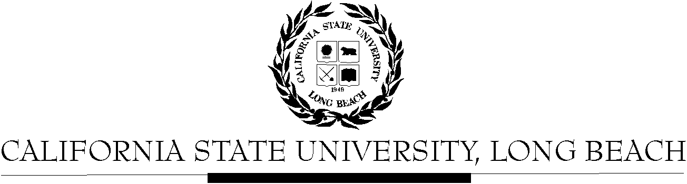

General Education Governing Committee

Agenda
September 12, 2016
2:00pm – 4:00pm – Office of the President Conference Room, BH-302

Please notify a member of the GEGC Executive Committee (Danny.Paskin@csulb.edu, Grace.Reynolds@csulb.edu Ruth.Piker@csulb.edu or Vanessa.Red@csulb.edu) if you are unable to attend.

- Call to Order

- Approval of Agenda

- Approval of Minutes: GEGC Minutes posted on BeachBoard

- Announcements
- Follow-up discussion on GEGC procedures and information
    - Enforcement of Standard Learning Outcomes and associated terminology
    - Website

- Items still tabled:
  - CHLS 100: Introduction to Chicano & Latino Studies

- Current Business
  - To be Untabled: None
  - New Submissions:
    - IST/WGSS 339: Global Feminisms
      - Posted on BeachBoard/GE Course Proposals Fall 2016
      - New to General Education
      - Request for Social Sciences & Citizenship, Capstone: Interdisciplinary, Global Issues
    - IST 399: Contemporary Global Divisions of Labor
      - Posted on BeachBoard/GE Course Proposals Fall 2016
      - New to General Education
      - Request for Social Sciences & Citizenship, Capstone: Global Issues (please disregard request for Interdisciplinary capstone for now)
    - CHLS 430: The Latino Transnational Experience in the Caribbean: Empire, Reform and Revolution
      - Posted on BeachBoard/GE Course Proposals Fall 2016
      - Existing to General Education
      - Request to continue Social Sciences & Citizenship
      - Request for Global Issues
    - CHLS 345: Latino/a Leadership in STEM
      - Posted on BeachBoard/GE Course Proposals Fall 2016
      - New to General Education
      - Request for Capstone: Writing Intensive; Human Diversity

- Future Business: None
- Adjournment
- Future Agenda/Discussion Items: None

