Academic Senate of California State University, Long Beach
Year-End Report 2010-11
International Education Committee
June 30, 2011

Written By: Richard R. Marcus, Chair, IEC
Membership:

Last Name | First Name | Department, College
Smith | Ed | Management/Human Resource Management, CBA
Washburn | Mark | Management/Human Resource Management, CBA
An | Shuhua | Teacher Education, CED
Portnoi VICE-CHAIR | Laura | Advanced Studies in Education & Counseling, CED
Washington | Thomas | Social Work, CHHS
Blazey | Michael | Facilities & Technical Planning, CHHS
Serrano | Nhora | Comparative World Literature & Classics, CLA
McEneaney | Elizabeth | Sociology, CLA
Velcic | Vlatka | Comparative World Literature & Classics, CLA
Marcus CHAIR | Richard | International Studies Program, CLA
Kelty | Thomas | Science Education, CNSM
Martin (Dunlop) | Catherine | Science Education, CNSM
Sciortino | Antonella | Civil Engineering & Construction Engineering Management, COE
Saadeh | Shadi | Civil Engineering & Construction Engineering Management, COE
Anglin | David | Music, COTA
Silveira | Carlos | Art, COTA
Herscovitz | Heloisa | Journalism, CLA
Meisel Lusby | Carolin | Recreation, CHHS
VACANT
VACANT
VACANT
Rivera- Chang | Jose | Design, COTA
Bosch | Eileen | University Library
Hagen- Crowder | Teresa | University Relations
Maravillas | Jennifer | Associated Students, Inc.
Burkard | Casey | Associated Students, Inc.
Allen | Terre | Faculty Center for Professional Development, Academic Affairs
Vazquez-Ramos | Armando | Chicano & Latino Studies
Curtis | Ken | International Education & Global Engagement, Academic Affairs
George | Simon | Physics & Astronomy
Jensen | Nathan | International Education & Global Engagement, Academic Affairs
Kennedy | Leslie | Instructional Technology Support Services
Lee | Robin | Career Development Center, Student Services
Joshee | Jeet | CCPE
Browne | Elson | Housing & Residential Life
Hostetler | Michael | Student Services
Reis | Raul | Journalism, CLA
VACANT
Joshee | Jeet | CCPE

Chair: Richard R. Marcus
Vice-Chair: Laura Portnoi
Recording Secretary: Leslie Kennedy

INTRODUCTION:
The International Education Committee (IEC) is an Academic Senate Standing Committee reporting to the Curriculum and Educational Policies Council (CEPC). Meetings are scheduled for the first Friday of every month 11:30-1:30. Meetings were held throughout the academic year except for January (winter break), September, and November (discussed below).

OVERVIEW OF THE YEAR:

2010-11 was a year of significant change for the IEC. The Chair, Richard Marcus, and Vice-Chair, Laura Portnoi, were elected. There was a recognition by members at the end of the 2009-10 year that the IEC needed to reconsider its mission and charge and they were elected largely with a mandate to do so. There mandate was given new urgency as there was a significant structural shift in International Education administration in the summer of 2010. The position of Assistant Vice President for International Education and Global Engagement was merged with the position of Dean of CCPE, making Jeet Joshee Dean of CCPE and Associate Vice President of International Education. The Center for International Education moved under CCPE. As a direct result of these changes Provost Don Para formed an International Education Task Force to consider innovations in the way CSULB delivers International Education on the CSULB campus. The composition of the Task Force was to include the major campus stakeholders in International Education. As such, the Chair of the IEC was a designated member of the Task Force. The IEC was given a second seat on the Task Force and the membership voted Laura Portnoi into that position. IEC reforms, first discussed in Spring 2010, were ultimately done following administrative shifts and in coordination with Task Force efforts.

In an August 2010 meeting, following the administrative shift, the consensus of the IEC Officers and Steering Group was that the following areas needed to be addressed within the IEC: the mission and charge, the composition of the membership (both to reduce the unusually large size and to bring it into greater compliment with the new administrative structure), and a reassessment of how the committee undertakes its charge to ensure that the focus is more squarely on issue of shared governance and curricular innovations and less on administration and administrative support. The magnitude of the workload associated with this led the Chair and Vice Chair to agree, with the support of the Steering Group, to a modification of the modus operandi for meeting organization. Prior to the start of the Academic Year members were asked to sign up to serve in one of the following “ad hoc working groups”:

• Ad hoc working group for mission statement
1. Emyr Williams
2. Jose Rivera Chang
3. Laura Portnoi (Chair)
4. Nathan Jensen
5. Nilufer Medora (non-voting)

• Ad hoc working group for the curricula/collaborations
1. Antonella Sciortino
2. Carolyn Lusby
3. Carlos Silveira
4. Sharon Olson (non-voting) (Chair)
5. Tom Kelty
6. Leslie Kennedy

• Ad hoc working group for international students
1. Eileen Bosch
2. Robin Lee (Chair)
3. Nora Serrano
4. Rebecca Groff

• Ad hoc working group for grants
1. Shuhua An
2. David Anglin
3. Teresa Hagen-Crowder
4. Heloiza Herscovitz
5. Shadi Saadeh (Chair)
6. Mark Washburn

• Ad hoc working group for development
1. Elaine Haglund (non-voting)
2. Richard Marcus
3. Armando Vazquez-Ramos (Chair)
4. Vlatka Velcic

In order to give appropriate time for the working groups to form their own mission and action plans and begin carrying them out, the general meeting of the IEC was suspended for September and November 2010. The members met during the regular IEC meeting time in their working groups instead.

The most challenging of these efforts was of course the revision of the mission and charge. The working group conducted a member survey. This survey brought out key issues to address. The working group then asked the IEC Chair, Richard Marcus, and Vice-Chair, Laura Portnoi, to propose language for the changes. The IEC members voted unanimously in support of this at the December meeting. Over winter break the chair and vice chair came up with a bulleted framework for changes. This was approved unanimously by vote of the full IEC at the February meeting. The chair and vice-chair took this framework to the Task Force to ensure efforts were complimentary with other International Education efforts on campus. Having received that support, they introduced specific language, sent it to the working group for modifications, and then to the IEC as a whole for the March meeting. The mission and charge proposed (with change in membership) was as follows:

Mission
The International Education Committee (IEC) strives to develop and sustain a comprehensive international ethos throughout the California State University, Long Beach (CSULB) campus community. The IEC promotes global literacy at CSULB by fostering the internationalization of curricula and encouraging international experiences among faculty, staff, and students.

Charge
The duties of the International Education Committee shall include, but not be limited to, the following:

- Promoting a collaborative effort toward a “globally engaged campus community” as stated in the CSULB Mission Statement;
- Proposing and revising policies related to International Education;
- Collaborating with colleges, departments, and the Associate Vice President for International Education to encourage and facilitate interdisciplinary curricular and programmatic internationalization;
- Providing guidance, recommendations, and advocacy for International Education;
- Supporting faculty efforts related to International Education;
- Contributing advice and recommendations on International Educational linkages;
- Encouraging efforts that enhance funding for International Education-related initiatives and research;
- Coordinating the work of International Education Committee subcommittees and working groups pertaining to International Education;
- Submitting an annual report of the committee's activities to the chair of the Curriculum and Educational Policies Council (CEPC).

Membership
- *Associate Vice President, International Education, or designee
- *Senior Director, Center for International Education, or designee
- *Director, Education Abroad
- Two (2) tenured, tenure-track, or lecturer faculty members from College of the Arts
- Two (2) tenured, tenure-track, or lecturer faculty members from College of Business
- Two (2) tenured, tenure-track, or lecturer faculty members from College of Education
- Two (2) tenured, tenure-track, or lecturer faculty members from College of Engineering
- Two (2) tenured, tenure-track, or lecturer faculty members from College of Health and Human Services
- Four (4) tenured, tenure-track, or lecturer faculty members from College of Liberal Arts
- Two (2) tenured, tenure-track, or lecturer faculty members from College of Natural Sciences and Mathematics
- Two (2) tenured, tenure-track, or lecturer librarians from University Library Services recommended by the Academic Senate Nominating Committee
- Three (3) staff members, selected by the Staff Council
- Two (2) students, selected by the Associated Students, Inc.
- One (1) member of the Curriculum and Educational Policies Council selected by the council, who should also be a member of the International Education Committee if possible; if an individual with dual membership is not available, the council member becomes a non-voting member of the International Education Committee

Members shall serve staggered, three-year terms and may be re-elected, but shall serve no more than two consecutive terms.

*Non-voting, ex-officio member

Governance
The committee is led by a Steering Group, comprised of an elected chair, vice chair, recorder, member- at-large, in addition to the Associate Vice President, International Education, and the Senior Director, Center for International Education.

The debate in the full IEC was significant over these changes. There were two significant issues in question: 1) whether ex-officio members should be voting or non-voting and 2) whether CCPE should have a faculty representative as other Colleges do. The chair moved to vote for approval of all aspects of the proposed mission, charge, and membership except these two issues, tabling these two aspects for a second vote until the April meeting, allowing time to seek further information on Senate rules and norms. The membership of the IEC voted unanimously passing all but these two elements. Despite this further input at the April meeting the IEC had a split vote nearly evenly bifurcated on both of these questions. The committee members then voted unanimously to refer the mission, charge, and membership to the CEPC as stands with notation that it is split on these two elements. This was sent to Chris Brazier, Chair of CEPC, on April 22. This was too late for the CEPC to consider the revised mission and charge in the 2010-11 year so it was carried over until Fall 2011.

The grants working group met with the AVP for Research, TC Yih, thrice. The result was that “international” was chosen by the AVP as an experimental interdisciplinary “pull” category in the forthcoming grants database and the groundwork for creating a specialized workshop for international-related grant-writing from across departments and colleges. The international students working group led to an important internal mission. It improved IEC coordination with CIE and CDC efforts. It also worked closely with AVP Jeet Joshee while he looked towards reinventing the process and services for international students. While the IEC has no role in that administrative process, it led discussion on innovations in how to better integrate students into mainstream academics. The curriculum working group wrote a mission and charge for its own efforts. Most of it is yet to be acted upon. However, this is largely because the members of the working group became instrumental in designing the Incentive Award instrument (below). Development met with the AVP for Development on two occasions and with the assigned development officer for CCPE. It made important strides in untangling how to seek cross-campus, interdisciplinary international-specific development funds within a college-based development structure.

In Fall 2010 an additional ad-hoc working group was formed within the IEC in support of the Provost’s International Education Task Force. The Task Force was quick to recognize that the work effort of its research would out-strip its membership. With the support of the chair and vice-chair of the IEC, and the approval of the IEC membership, it thus charged the ad-hoc working group of the IEC in support of the Task Force with conducting a survey of international education structures and norms at other universities. This group was comprised of Raul Reis, Aparna Nayak-Guercio, Shuhua An, Nathan Jensen, Richard Marcus, Laura Portnoi, and Elaine Haglund. That working group broke down other universities into 1) other CSUs 2) Southern California UCs, and 3) “like” universities in other parts of the country. That survey was then written up as a report and given with the raw data results to the Task Force to integrate with its other data and serve its findings.

Incentive Award for Globalizing Instruction

Funds from the AVP for International Education were matched by a donor for creating an Incentive Award for Globalizing Instruction. The guidelines of that award were largely designed by a combination of the curriculum group, the IEC Chair, and the AVP for International Education. The guidelines can be found in addendum. A different group of volunteers from the IEC membership formed a review group. The members included Eileen Bosch (Chair), Mark Washburn, Carlos Silveriera, Carolin Lusby, and Vlatka Velcic. The Chair of the IEC served as point of contact for enquiries about the award but did not serve on the award review group. The IEC membership voted unanimously at the May meeting to approve the awards as recommended by the review group. Awardees can be found in addendum.

Recommendations to Approve MOUs for Bilateral Agreements

As a matter of process bilateral agreements for international exchanges are written by the Director of Education Abroad in consultation with the Executive Director of the CIE. They are then brought to the International Education Committee to recommend approval, amendment, or rejection. The ultimate decision is then left to the AVP for International Education in consultation with the Provost and President. The IEC unanimously recommended the following programs to the AVP:

- University of Kent, UK
- Glasgow Caledonia University
- Ca' Foscari, Venice, Italy
- Mahidol University, Thailand
- Ollscoil Luimnigh/University of Limerick (Ireland)
- Josai International University (Japan)

Geographic Area Subcommittees of the IEC:
Traditionally, the committee has helped develop and supported the work of the following Geographic Area Subcommittees: African Studies, East Asian Studies, European Studies, Latin American Studies, Middle/Near East Studies, and South Asian Studies. There was no money to support any activities of the Area Subcommittees this academic year. The members of the IEC were taxed in their efforts directly to the IEC. Despite all of that, some of the established sub-committees continued their many activities; others were not able to meet. During 2010-11 the most active area sub-committees that organized numerous educational events and research projects on campus were: South Asian Studies and Middle East/Near East Studies.

IEC Beachboard Site:
Prior to the start of the 2010-11 academic year the Chair and Vice-Chair, with the support of Leslie Kennedy acting both as recording secretary for the IEC and the CSULB Director of Technology, reconstituted the IEC Beachboard site. It became the primary mechanism for communicating with members and the agenda and minutes could be posted to it. Towards the end of the year the “old” site, which is comprised of some 300+ people on campus with interests in international education, was reconstituted to create an international education listserv to disseminate information about international education (rather than serve the IEC). The Chair of the IEC and a representative from CCPE co-host the list.

Elections:
Elections for officers were held at the May meeting. The Chair, Richard Marcus (Liberal Arts) and the Vice-Chair, Laura Portnoi (Education) found over the course of the academic year that they had very complimentary skill-sets. They ran as co-chairs for 2011-12. They were elected co-chairs with Leslie Kennedy elected as vice-chair and Mark Washburn (Business) elected recording secretary. The IEC membership voted unanimously to give them a mandate to actuate many of the changes created in 2010-11.
Appendix A: Guidelines for the Incentive Award for Globalizing Instruction
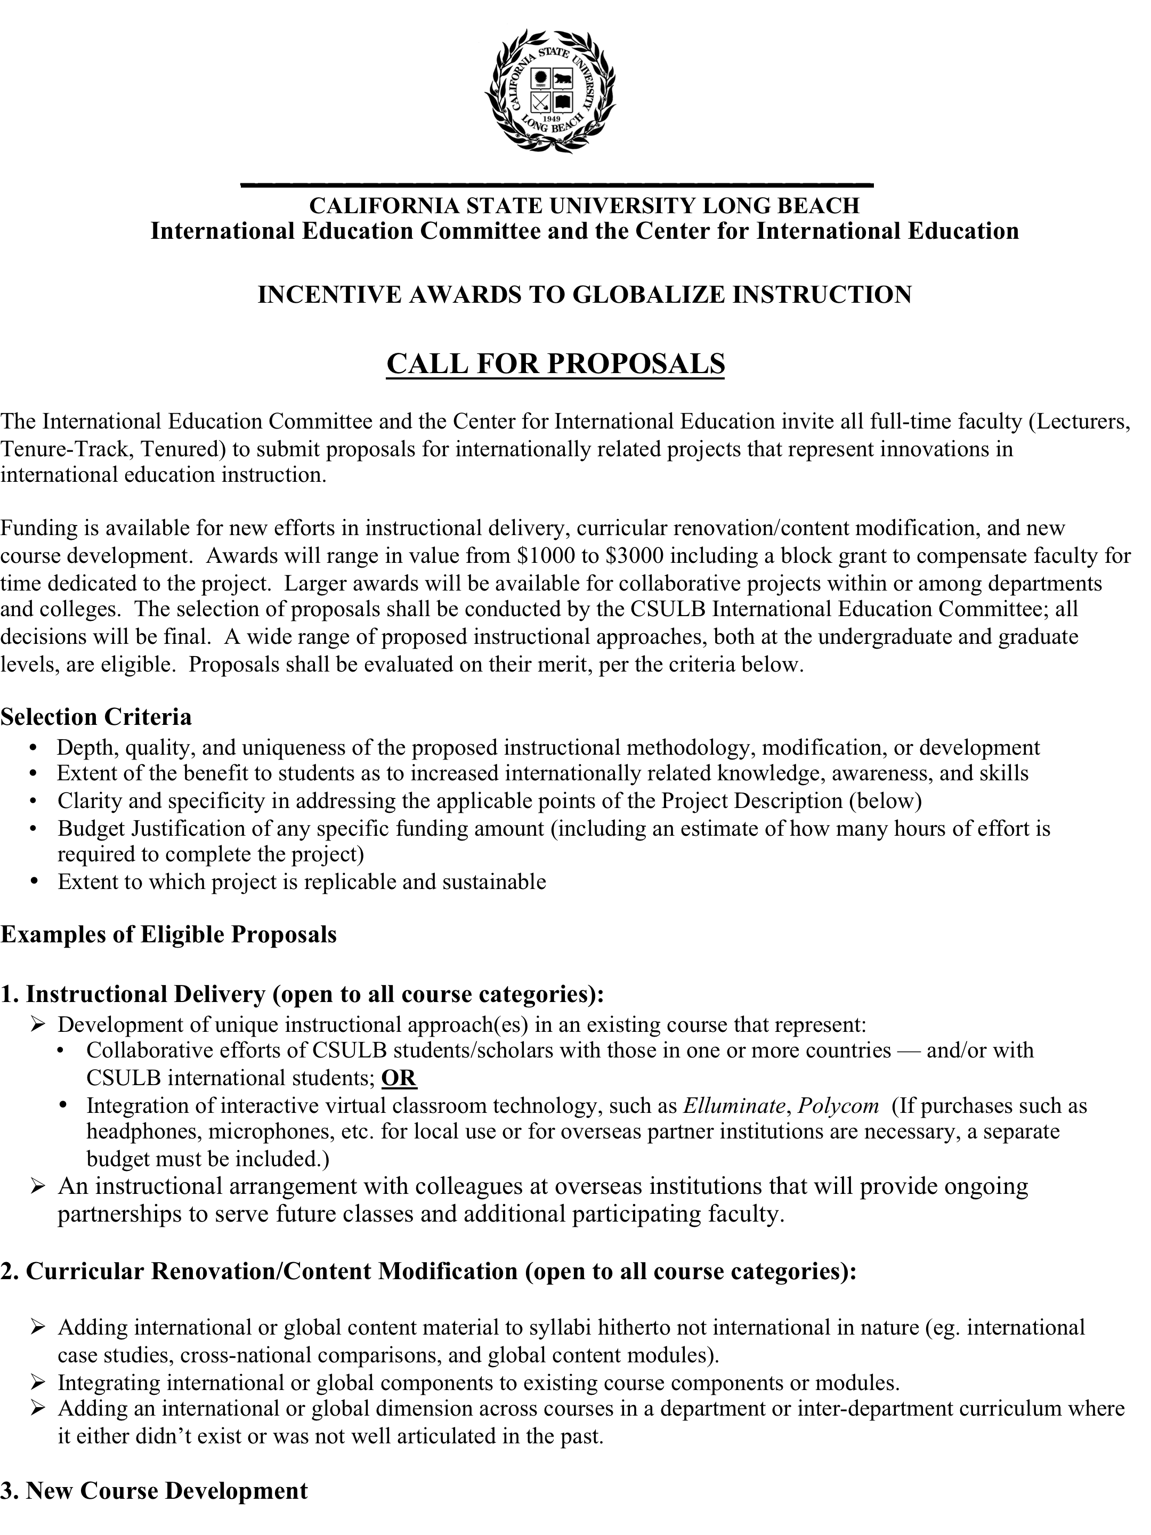
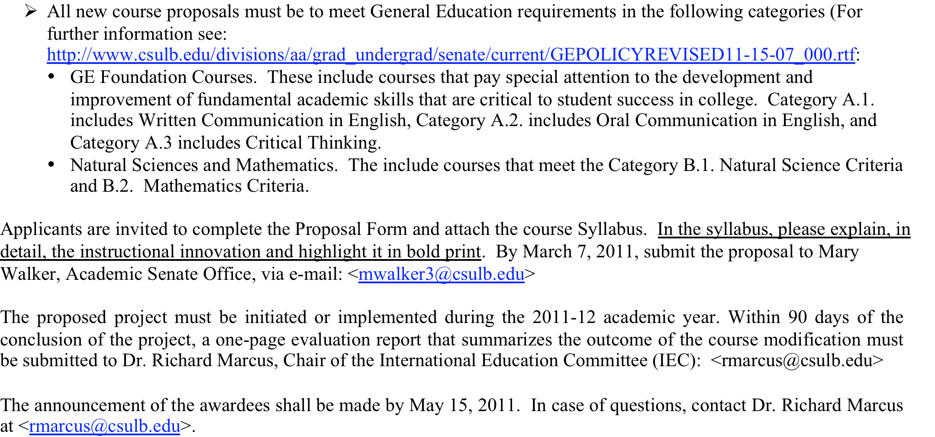
Appendix B: Recipients of an Incentive Award for Globalizing Instruction
