Appendix A1
Example of a Comprehensive Program Assessment Plan
MS Nutrition
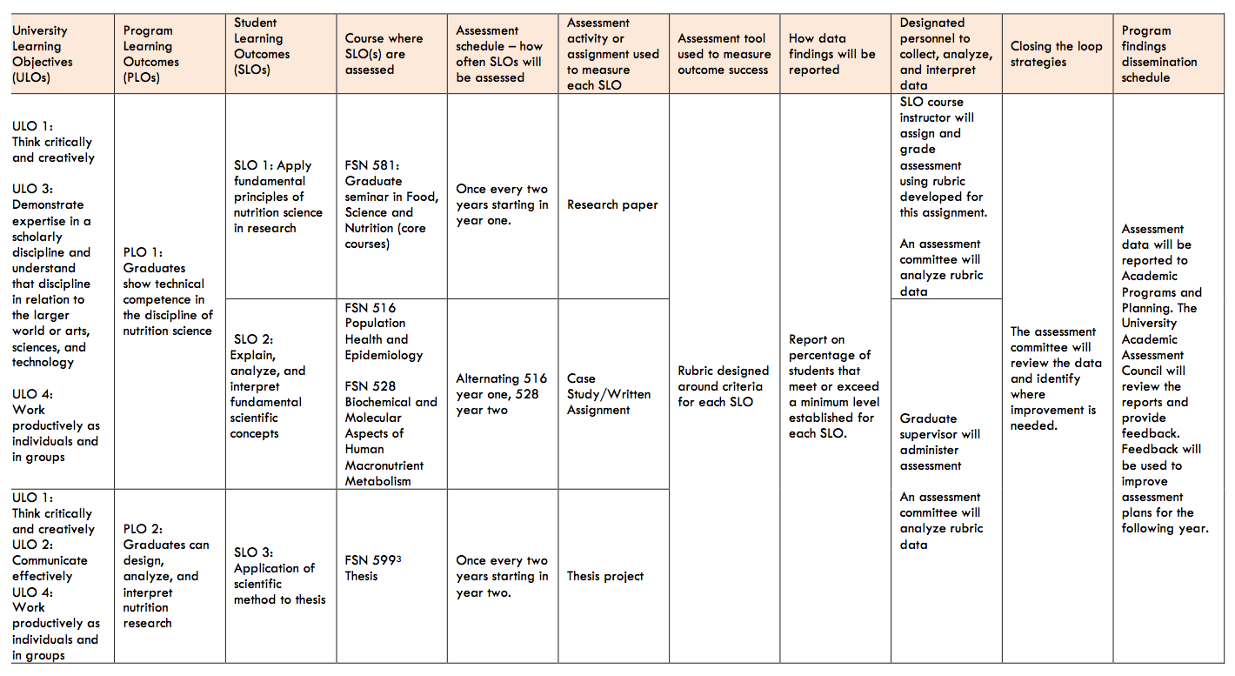

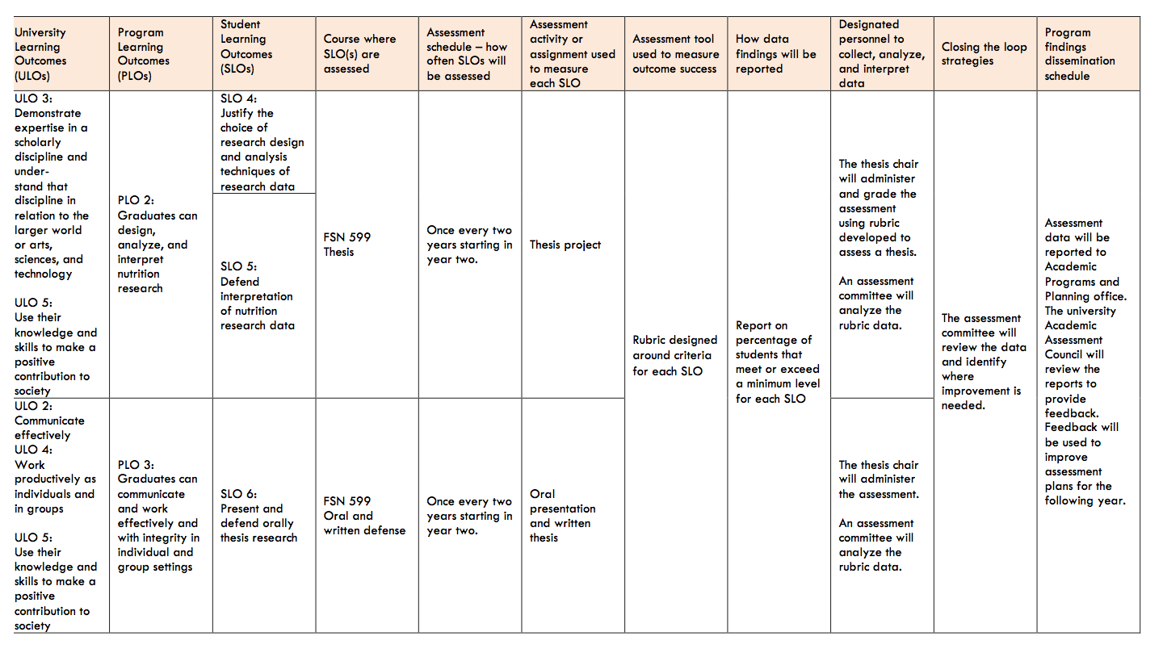

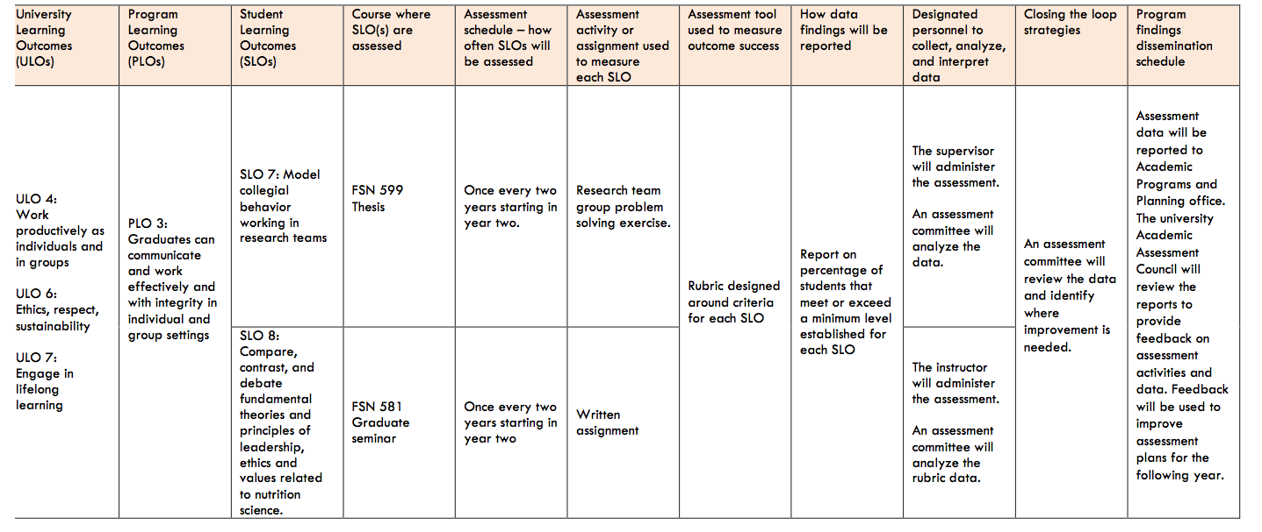
Template originally created by Mary Pederson and San Luis Obispo faculty.

Appendix A2
Example of a Curriculum Mapping Matrix
MS Nutrition
 | COURSE FSN 581 Grad Seminar in Food, Science, and Nutrition | COURSE FSN 528 Biochemical and Molecular Aspects of Human Macro-nutrient Metabolism | COURSE FSN 529  Metabolic Molecular Aspects of Vitamins | COURSE FSN 530  Metabolic and  Molecular Aspects of Minerals | COURSE FSN 516  Population, Health and Epidemiology | COURSE  FSN 599  Thesis
SLO 1: Explain and apply fundamental principles of nutrition science | I/D/M
SLO 2: Describe, analyze, interpret and apply fundamental scientific concepts | I | D | D | D | M
SLO 3 Apply scientific method in thesis |  |  |  |  | I/D | M
SLO 4 Justify the choice of research design and analysis techniques of research data |  |  |  |  | I/D | M
SLO 5 Defend interpretation of nutrition research data | I | D | D | D | D | M
SLO 6 Present and defend orally thesis research | I | D | D | D | D | M
SLO 7: Model collegial behavior working in research teams | I |  |  |  | D/M
SLO 8: Compare, contrast, and debate fundamental theories and principles of leadership, ethics and values related to nutrition science. | I/D/M

Appendix B1
Sample Comprehensive Program Assessment Plan
MA in Reading (assessment of SLOs in core courses of the major)
a | b | c |  | d | e | f | g | h | i | j | k
ILOs | PLOs |  | SLOs | Course  where SLO is assessed | Assessment activity  (signature assignment) used to measure each SLO | Assessment tool used to measure outcome success | Assessment schedule – how often SLOs will be assessed | How assessment data will be reported as evidence SLO performance criteria have been met | Designated personnel to collect, analyze, and interpret student learning outcome data for the program | Student learning outcome data dissemi-  nation schedule | Closing the loop strategies
ILO 1: Thinking and Reasoning: Think critically and creatively;  apply analytical and quantitative reasoning to address complex challenges and everyday problems | PLO 1: Graduates will apply theory and research results to promote a culture of literacy in diverse families and community. |  | SLO 1:  Students will design and implement a research based assessment and intervention strategy to address learners’ literacy needs. | TED 664 | Assessment and intervention design and implement-ation project | 5 point rubric measuring all aspects of effective literacy project design | End of every even numbered year | % of all students scoring at a 4 or 5 on design project | College assessment coordinator and designated program faculty | Every other year | Assessment committee analysis, share with faculty, collabora-tively develop appropriate strategies based on identified areas of need. These might include revising syllabi, revising SLOs and signature assignment.
ILO 2:  Communication  Communicate ideas, perspec-tives and values clearly and persuasively while listening openly to others | PLO 2:  Students will communicate and demonstrate research based instructional practices related to literacy. |  | SLO 2:  Students will teach a literacy lesson in an educational setting using a research based literacy instruct-tional technique. | TED 661 | Instructional lesson plan and teaching episode | 5 point rubric measuring competency in all criteria of effective communi-cation and  teaching of literacy technique | End of every odd numbered year | % of all students scoring at a 4 or 5 on lesson plan and teaching episode | College assessment coordinator and designated program faculty | Every other year | Assessment committee analysis, share with faculty, collabora-tively develop appropriate strategies based on identified areas of need. These might include revising syllabi, revising SLOs and signature assignment.
ILO 3:  Collaboration: Work collabora-tively and respect-fully as members and leaders of diverse teams and community | PLO 3:  Graduates will display leadership and advocacy skills. |  | SLO 3:  Students will present all aspects of their research project to include problem ID, questions, methodol-ogy, findings, conclusions and implica-tions for advocacy. | TED 693 | Oral presen-  tation of final culminating project | Professor’s observa-tional checklist of presentation criteria. | End of every academic year | Number of students who meet 80% of observational presentation criteria. | College assessment coordinator and designated program faculty | Every year | Assessment committee analysis, share with faculty, collabora-tively develop appropriate strategies based on identified areas of need. These might include revising syllabi, revising SLOs and signature assignment.
ILO 4:  Diversity: Apply knowledge of diversity and multicultural competencies to promote equity and social justice | PLO 4:  Graduates will develop a balanced literacy environment addressing all required elements aligned with students’ assessed language and literacy needs. |  | SLO 4:  Students will evaluate needs of a school literacy program and recommend next steps to strengthen literacy environ-ment. | TED 664 | Analytical report | 5 point rubric measuring evaluation competency and logical next steps | End of year in even numbered years. | % of all students scoring a 4 or 5 on research project rubric | College assessment coordinator and designated program faculty | Every year | Assessment committee analysis, share with faculty, collabora-tively develop appropriate strategies based on identified areas of need. These might include revising syllabi, revising SLOs and signature assignment.
ILO 5:  Sustain-ability: Act responsibly at local, national and global levels | PLO 5: Graduates can analyze, interpret and discuss scholarly research in the literacy field. |  | SLO 5:  Students will conduct a compar-ative analysis of two literacy research studies. | TED 688 | Comparative analysis paper | 5 point rubric assessing comparative and analytical skills | End of year in odd numbered years. | % of all students scoring a 4 or 5 | College assessment coordinator and designated program faculty | Every year | Assessment committee analysis, share with faculty, collabora-tively develop appropriate strategies based on identified areas of need. These might include revising syllabi, revising SLOs and signature assignment.

Examples of signature assignment activities: case study, lab report, instructional lesson plan, final exam, presentation, performance, computer simulated tasks, analytical paper, portfolio, critique, policy paper, comparative analysis project, qualifying or comprehensive examination, observations, classroom response systems, qualifying or comprehensive examination, culmination experience project, thesis, dissertation, etc.

Examples of Assessment Tools (an instrument used to score or evaluate an assessment activity/assignment): Rubrics (that produce scores based on established criteria – can be used with most activities listed above), observational checklists, etc.

Examples of ways to report assessment data: number/percentage of those scoring at or above 4.0 on a 5.0 point scale on the assessment used to measure mastery of a specific SLO; number/percentage of students scoring at the highly proficient level; instructor observational narrative that includes analysis and findings to qualitatively show trends and patterns; mean scores of all who exhibited desired traits or behaviors on an observational checklist, etc.

Appendix B2
Sample Curriculum Map Matrix

MA Reading (SLOs and core major courses)
 | TED 660 Literacy Research and Methods | TED 661 Compre-hension Research and Methods | TED 662 Culture of Literacy: Focus on Diversity | TED 663  Literacy Assessment | TED 664 Literacy intervention | TED 688  Research in Education | TED 693  Project
SLO 1: Students will design and implement a research based assessment and intervention strategy to address learners’ literacy needs. | DDDD  I |  | D |  | I, D, M
SLO 2: Students will teach a literacy in an educational setting using a research based literacy instructional technique. | I | D | D |  | M
SLO 3: Students will present all aspects of their research project to include problem ID, questions, methodology, findings, conclusions and implications for advocacy. | I, | D |  |  |  | D | M
SLO 4: Students will evaluate needs of a school literacy program and recommend next steps to strengthen literacy environment. |  |  | I | D | M
SLO 5: Students will conduct a comparative analysis of two literacy research studies | I | D |  |  |  | D, M

Place I, D, or M in each cell above to indicate where the program content related to each SLO is introduced (I), developed (D), and/or mastered (M). SLO content may be delivered in more than just six courses as indicated in the above table.

